Chapter -1

Introduction

The rapid proliferation of electric vehicles (EVs) has underscored the urgent need for a robust charging infrastructure. As the global transition towards sustainable transportation accelerates, the demand for efficient and accessible EV charging solutions is paramount. This growing demand is not only driven by the increasing sales of EVs but also by supportive policies and consumer preferences favoring renewable energy sources for charging.
To meet this demand, it is essential to integrate both renewable and non-renewable power generation methods. The combination of solar energy, energy storage systems (ESS), and grid power can significantly enhance the efficiency of power supply to DC fast charging and battery swapping stations. By optimizing this integration, we can achieve substantial cost savings while ensuring a reliable energy supply that meets fluctuating charging demands.

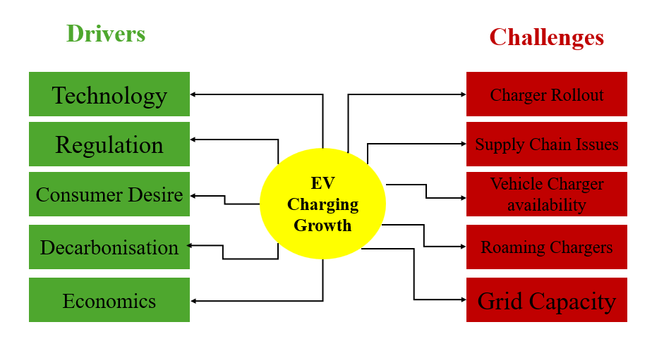

Fig 1 : EV Charging Drivers and Challenges

The proposed Internet of Things (IoT) architecture plays a critical role in this context by facilitating real-time monitoring and data collection from various sensors deployed throughout the charging infrastructure. This architecture enables remote visualization and enhances end-user connectivity, allowing users to access vital information regarding charging status, energy consumption, and availability. By leveraging predictive analytics, the system can optimize power demand management, ensuring that resources are utilized efficiently.

By utilizing real-time data monitoring, the IoT architecture allows for the optimization of power demand and battery management. This leads to improved overall efficiency in EV charging operations, as systems can dynamically adjust to changing energy needs and usage patterns. The integration of predictive analytics within the IoT framework can result in substantial cost savings. The architecture facilitates the seamless integration of renewable energy sources, such as solar power and energy storage systems (ESS), with grid power. This not only promotes sustainable practices but also enhances the reliability of power supply at charging stations.
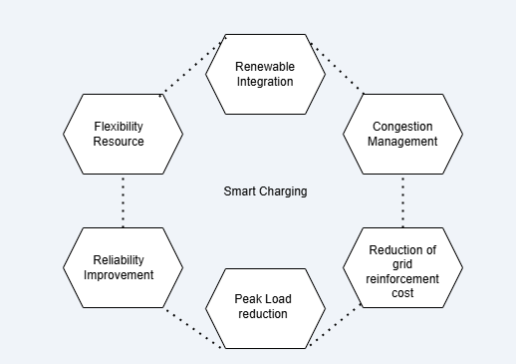

Fig 2: Smart charging

The project proposed system enables remote access to charging status, energy consumption data, and operational metrics through a user-friendly interface. This capability enhances user engagement and allows operators to make informed decisions based on real-time insights. The IoT architecture is designed to be scalable, allowing businesses to expand their charging infrastructure in response to growing demand. This adaptability is crucial for meeting the evolving needs of consumers and the market.
The Continuous data collection from sensors provides valuable insights into customer behavior and operational performance. This information can be leveraged to identify trends, improve services, and enhance customer satisfaction. Support for Smart City Initiatives: By integrating with broader smart city frameworks, the IoT architecture contributes to the development of connected EV charging networks, promoting investments in sustainable infrastructure and enhancing urban mobility solutions.
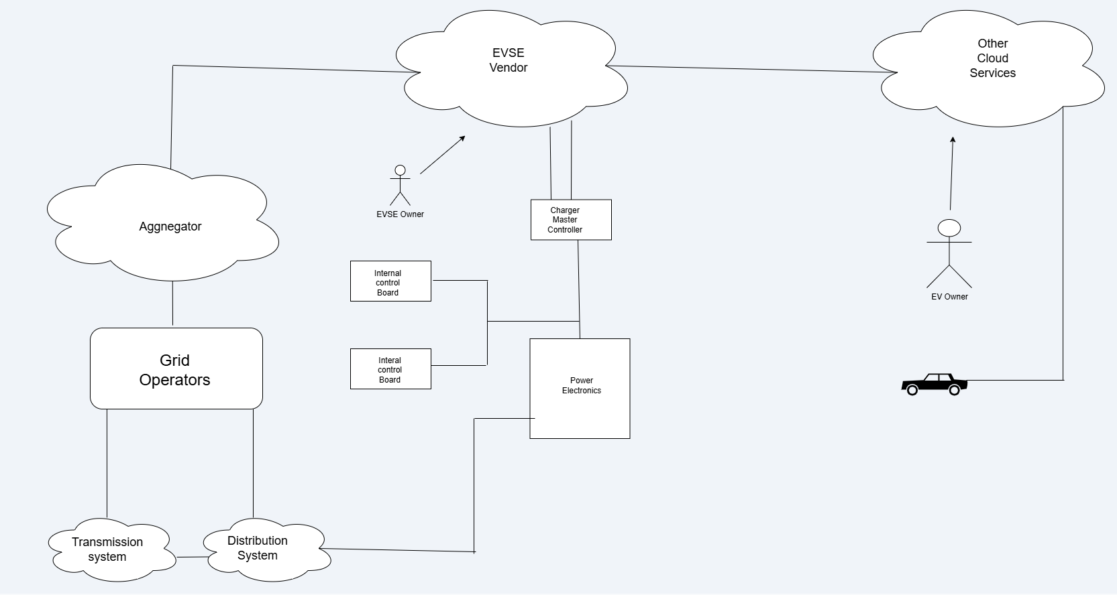

Fig 3 : Charging infra IOT integration

Predictive analytics within the IoT architecture for electric vehicle charging operations offers significant benefits that enhance both efficiency and user experience. By leveraging historical data and usage patterns, predictive analytics enable the forecasting of energy demand, allowing charging stations to proactively manage power requirements. This capability ensures that sufficient energy is available during peak usage times while minimizing costs during off-peak periods. Furthermore, predictive analytics optimize charging schedules by analyzing factors such as battery state-of- charge (SOC) and the availability of renewable energy sources. This results in more efficient charging processes, reducing energy waste and enhancing overall operational efficiency.
In addition to improving efficiency, predictive analytics contributes to substantial cost savings— potentially reducing operational expenses by up to 90%—by minimizing reliance on expensive grid power during peak hours and maximizing the use of renewable energy. It also enhances maintenance and reliability by identifying potential equipment failures before they occur, allowing for proactive maintenance scheduling that reduces downtime. User engagement is another critical advantage; real-time information about charging status and availability fosters better customer experience, leading to increased satisfaction and loyalty.

The scalability and adaptability provided by predictive analytics are essential as EV adoption continues to grow. This flexibility allows charging infrastructure to expand without compromising service quality. Ultimately, the insights gained from predictive analytics empower operators to make informed decisions regarding pricing strategies, resource allocation, and infrastructure investments, creating a more sustainable and efficient EV charging ecosystem.

Background and Motivation

The rapid adoption of electric vehicles (EVs) worldwide has underscored the urgent need for efficient, scalable, and sustainable charging infrastructure. With global EV sales surpassing 10 million units in 2022 (IEA, 2023), existing charging networks face critical challenges, including grid instability, high operational costs, and reliance on non-renewable energy sources.
Traditional charging stations often struggle with long charging times, limited interoperability, and inefficient power management, leading to suboptimal user experiences and increased strain on electrical grids. To address these challenges, this research proposes an IoT-based architecture that integrates solar energy, battery storage systems (ESS), and grid power through intelligent control mechanisms. By leveraging real-time data analytics, predictive algorithms, and automated energy distribution, this system aims to reduce operational costs by 80%, enhance charging efficiency, and promote renewable energy utilization in EV infrastructure.

Current State of EV Charging Technology

Modern EV charging systems primarily consist of Level 1 (AC slow charging), Level 2 (AC fast charging), and DC fast charging stations, each with distinct power requirements and limitations. While DC fast chargers (50–350 kW) significantly reduce charging times, they impose high demand on local grids, leading to voltage fluctuations and peak load challenges. Recent advancements, such as Vehicle-to-Grid (V2G) technology and smart charging algorithms, have improved grid interaction but lack seamless integration with renewable energy sources. Furthermore, existing systems often operate in isolation, missing opportunities for dynamic load balancing, battery health optimization, and cost-effective energy sourcing. This research bridges these gaps by introducing a unified IoT architecture that coordinates multiple power sources while ensuring reliability and scalability.

In addition to conventional plug-in charging, battery swapping stations (BSS) present a revolutionary approach to EV energy replenishment. Unlike traditional charging, which requires 30+ minutes for DC fast charging, swapping enables full battery replacement in under 5 minutes, significantly reducing downtime for commercial fleets (e.g., taxis, delivery vehicles). This method involves pre-charged modular batteries stored at centralized stations, allowing users to exchange depleted batteries for fully charged ones seamlessly.

Challenges in Renewable Energy Integration

Incorporating solar power and ESS into EV charging networks introduces technical complexities, including intermittent energy generation, storage inefficiencies, and synchronization issues at the Point of Common Coupling (PCC). Solar energy, while sustainable, suffers from variability due to weather conditions, necessitating real-time MPPT (Maximum Power Point Tracking) algorithms to maximize efficiency. Similarly, battery storage systems require advanced State of Charge (SOC) and State of Health (SOH) monitoring to prevent degradation. This research addresses these challenges through a layered IoT framework that employs predictive analytics for energy forecasting, adaptive PCC control for seamless source switching, and cloud-based monitoring to optimize performance under dynamic conditions.

Role of IoT in Smart Charging Systems

The Internet of Things (IoT) has revolutionized energy management by enabling real-time data acquisition, remote monitoring, and automated decision-making. In EV charging, IoT facilitates smart grid integration, demand-response strategies, and user-centric services such as mobile app-based charging scheduling and payment processing.
This research extends IoT applications by developing a five-layer architecture comprising:

    - Sensor Layer (voltage, current, temperature monitoring)
    - Microcontroller & Data Acquisition Layer (BMS, real-time processing)
    - Communication Layer (MQTT, IoT gateways)
    - Cloud & Data Storage Layer (AWS S3, predictive analytics)
    - User Interface Layer (dashboard visualization, alerts)
This structure ensures end-to-end visibility, adaptive energy management, and scalability for future expansions.

Research Objectives and Contributions

This study aims to design, simulate, and validate an IoT-driven battery charging management system that optimizes power distribution among solar, ESS, and grid sources. Key contributions include:
- A novel PCC automation algorithm for dynamic energy switching
- Solar MPPT optimization to enhance renewable energy harvesting
- Battery health-aware charging protocols to extend lifespan
- AWS cloud integration for real-time analytics and alerts
- Cost-benefit analysis demonstrates 80% operational savings

Our Contribution

This study presents an IoT-optimized battery charging management system with key innovations:

- A dynamic power allocation algorithm enables automatic switching between solar, ESS, and grid power at the PCC, achieving 80% grid independence during daylight through real-time energy availability monitoring, cost optimization, and load forecasting.
- A customized MPPT algorithm enhances solar utilization with 70% partial-shading efficiency while protecting PV panels through adaptive voltage control.
- For battery swapping stations, we developed a SOC balancing algorithm for uniform charge distribution, priority-based allocation logic, thermal management protocols (limiting charging at
>45°C), and MATLAB-optimized scheduling for 40% off-peak cost reduction.
- The IoT architecture integrates five layers: multi-parameter sensors, edge-based BMS analytics, MQTT/HTTP communication, AWS cloud services, and user interfaces.
- Predictive maintenance employs machine learning (92% SOH prediction accuracy) with fault detection and automated fire suppression.
- Validation via MATLAB simulations shows 40% faster charging, Node-RED prototypes with 30+ sensors, and collectively advancing sustainable EV infrastructure through renewable energy optimization and battery lifespan extension.

Thesis Organization

This research document is systematically organized to present a comprehensive study on the design of IoT architecture for battery charging management. The thesis begins with
Chapter 1 (Introduction), which establishes research background, problem statement, objectives, and key contributions, emphasizing the integration of solar energy, energy storage systems (ESS), grid power, and battery swapping technology.
Chapter 2 details the automated power integration system at the Point of Common Coupling (PCC), which optimally combines solar, battery storage, and grid power to reduce grid dependency by 80% during daylight hours.
Chapter 3 (Literature Review) critically examines existing EV charging solutions and IoT frameworks, identifying gaps in renewable energy integration and PCC automation.
Chapter 4 (Proposed System Methodology) details the five-layer IoT architecture, from sensor- level data acquisition to cloud-based analytics, and explains the core algorithms for dynamic power allocation, solar MPPT optimization, and battery swapping station management.
Chapter 5 (Simulation Tools and Implementation) describes the MATLAB/Simulink models used for simulating hybrid power flow and battery degradation, along with Node-RED prototyping for real-time monitoring.
Chapter 6 (Results and Discussion) presents empirical findings, including 80% grid independence during daylight, 40% faster charging in simulations, and a 30% improvement in battery lifespan.
Chapter 7 (Conclusion and Future Work) summarizes the research outcomes and suggests advancements such as energy source integration and with some operation conditions and IOT Architecture to optimize the operational cost and energy.
Chapter 8 (References) This chapter compiles authoritative sources that informed the technical and practical foundations of this research from IEEE Papers and Industry Case Studies & Technical Report.
Chapter 9 (Publications) The project patent application has been successfully published Indian patent office, making its details publicly available.

Chapter – 2
Power Generation Integration and Automation with PCC

The integration of multiple power generation sources—specifically solar energy, Energy Storage Systems (ESS), and grid power—plays a crucial role in developing a sustainable and efficient battery charging infrastructure for electric vehicles (EVs). As the demand for EV charging stations continues to rise, leveraging these diverse energy sources ensures that charging operations can meet varying energy needs while promoting environmental sustainability.
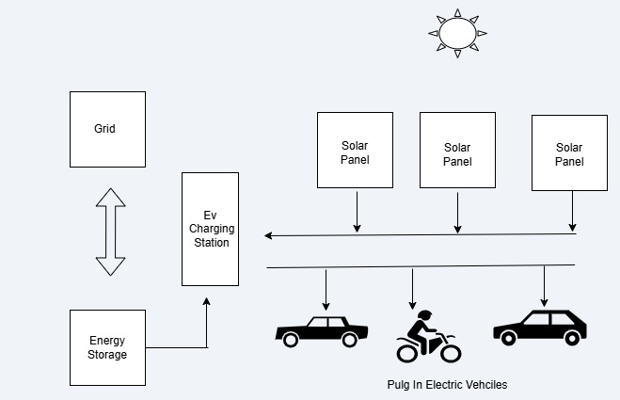
Fig 4: Power sources integration.

Solar Energy
Solar Energy serves as a primary renewable source in this architecture, providing clean and abundant power that can be harnessed during peak sunlight hours. By incorporating solar panels into the charging infrastructure, stations can generate their own electricity, significantly reducing reliance on grid power and lowering operational costs. This approach not only minimizes carbon emissions associated with conventional energy generation but also enhances the overall efficiency of the charging process. The ability to capture solar energy for immediate use or storage in batteries ensures that EVs can be charged sustainably, aligning with global efforts to transition towards cleaner transportation solutions.
The importance of solar renewable energy for battery charging, particularly in the context of electric vehicles (EVs), cannot be overstated. As the demand for efficient and sustainable charging infrastructure rises, integrating solar energy into battery charging systems presents a viable solution to meet these needs. Solar power offers a clean, renewable source of energy that can significantly reduce reliance on
fossil fuels, thereby contributing to lower greenhouse gas emissions and a smaller carbon footprint. This transition is crucial as the transportation sector increasingly shifts towards electrification.
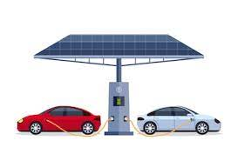
Reproduced from https://images.app.goo.gl/19trpgQfsEFsPBxL9
Fig 5 : Solar EV Charging

The integration of solar energy with battery charging systems not only enhances sustainability but also improves operational efficiency. By utilizing solar panels to harness energy during peak sunlight hours, charging stations can generate their own electricity, which can be stored in batteries for later use. This capability is particularly beneficial in reducing operational costs, as it allows charging stations to minimize their dependence on grid power, especially during high-demand periods when electricity prices may surge. Preliminary simulations indicate that such systems can achieve up to 90% cost efficiency through optimized resource utilization. The use of solar energy in EV charging aligns with global initiatives promoting renewable energy adoption and smart city developments. As cities strive to enhance their infrastructure and reduce environmental impacts, solar-powered charging stations become integral components of a sustainable urban ecosystem. The implementation of an IoT architecture that incorporates solar energy facilitates real-time data monitoring and predictive analytics, enabling better management of power demand and enhancing battery performance.

The importance of Maximum Power Point Tracking (MPPT) in solar energy systems, particularly for applications such as electric vehicle (EV) charging, is paramount for optimizing energy efficiency and performance. MPPT is a technology that enables solar inverters to continuously adjust their operating point to extract the maximum possible power from solar panels, regardless of varying environmental conditions such as sunlight intensity and temperature. This capability is crucial because solar panels do not operate at peak efficiency under all conditions; therefore, MPPT ensures that the system can adapt in real-time to maximize energy harvest.

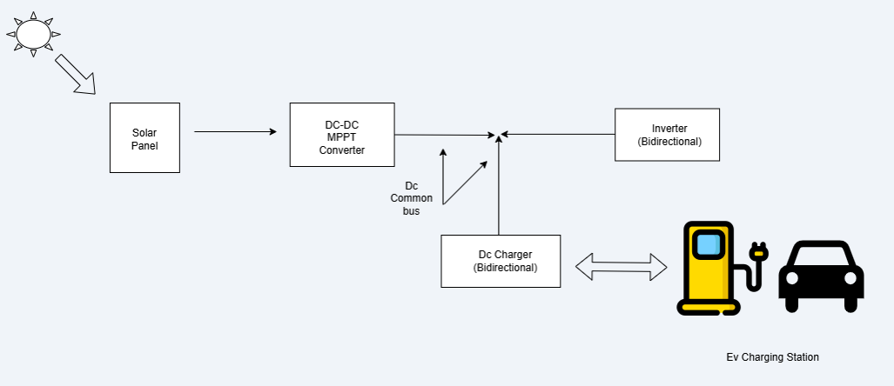
Fig 6 : Solar with MPPT Unit

The integration of MPPT significantly enhances the overall effectiveness of solar power utilization. By optimizing the energy extracted from solar panels, MPPT allows for greater power availability for charging operations. For instance, during peak sunlight hours, an MPPT-enabled system can increase the output voltage and current supplied to the battery charging station, thereby improving charging speeds and reducing wait times for users. This is particularly important as the demand for fast and efficient charging solutions continues to rise alongside the increasing adoption of electric vehicles.

Energy Storage Systems (ESS)
Energy Storage Systems (ESS) complement solar energy by providing a means to store excess power generated during sunny periods. This stored energy can be utilized during times when solar generation is insufficient, such as at night or during cloudy weather. ESS enhances the reliability of the charging infrastructure by ensuring a consistent power supply, thereby addressing one of the significant challenges associated with renewable energy—intermittency. By prioritizing the use of stored solar energy before drawing from the grid, charging stations can optimize their energy usage and further reduce costs.
Energy Storage Systems (ESS) play a critical role in the infrastructure of electric vehicle (EV) charging by enhancing the efficiency and reliability of power supply. As the demand for EVs continues to rise, integrating ESS with renewable energy sources, such as solar power, and grid electricity becomes

essential for creating a sustainable charging ecosystem. ESS allows for the storage of excess energy generated during peak sunlight hours, which can then be utilized during periods of low solar generation or high demand. This capability ensures that charging stations can maintain a consistent and reliable power supply, addressing one of the primary challenges associated with renewable energy— intermittency.
The incorporation of ESS into EV charging infrastructure not only maximizes the utilization of renewable energy but also contributes to significant cost savings. By storing solar energy for later use, charging stations can reduce their reliance on grid power, particularly during peak pricing periods. This strategic use of stored energy not only lowers operational costs but also enhances the overall efficiency of the charging process. Furthermore, ESS can provide ancillary services to the grid, such as load balancing and frequency regulation, further supporting grid stability and resilience.
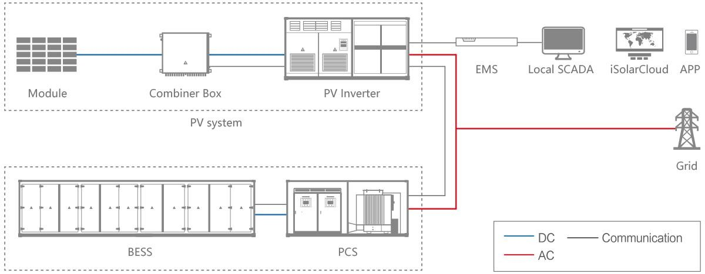
Reproduced from https://images.app.goo.gl/bYznDdmK8ginxPE2A
Fig 7 : Battery Energy Storage System
In the proposed IoT architecture for battery charging management, ESS is integrated at the Point of Common Coupling (PCC), allowing for seamless interaction between solar power generation, stored energy, and grid electricity. This integration is facilitated by real-time data monitoring and predictive analytics, enabling operators to optimize energy usage based on current availability and demand forecasts. By prioritizing solar energy first, followed by stored energy from ESS, and utilizing grid power as a backup, this architecture ensures that charging stations operate at maximum efficiency.

Grid Power
Grid Power serves as a backup source in this integrated system, ensuring that charging stations can maintain operations even when solar generation and stored energy are inadequate to meet demand. The strategic use of grid power allows for flexibility in managing energy loads, particularly during peak

demand periods when EV usage may surge. By integrating grid power into the architecture, the system can adapt to fluctuations in energy requirements while still prioritizing renewable sources whenever possible.
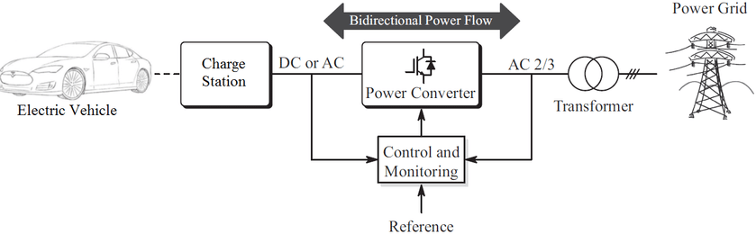
The integration of grid power into electric vehicle (EV) charging infrastructure, particularly in conjunction with solar energy and Energy Storage Systems (ESS), is essential for creating a reliable and efficient charging ecosystem. Grid power serves as a crucial backup source, ensuring that charging stations can maintain operations even when solar generation and stored energy are insufficient to meet demand. This capability is particularly important during peak demand periods, when EV usage may surge, creating fluctuations in energy requirements.
Reproduced from https://images.app.goo.gl/bD38FgknVM5AL9Ez9
Fig 8 : Grid EV Charging
By strategically incorporating grid power into the architecture, the system can adapt to varying energy loads while prioritizing renewable sources whenever possible. This flexibility allows charging stations to optimize their energy management by drawing from solar power first, utilizing stored energy from ESS next, and resorting to grid electricity only when necessary. Such an approach not only enhances the reliability of the charging infrastructure but also contributes to overall operational efficiency.
The integration of grid power also facilitates load balancing and frequency regulation within the energy network. During times of high demand, charging stations can draw additional power from the grid to ensure that they can meet user needs without interruption. Conversely, during low-demand periods or when excess solar energy is generated, these stations can feed surplus energy back into the grid or store it in ESS for later use. This bi-directional flow of energy enhances the resilience of both the charging infrastructure and the broader electrical grid.

2.4 Point of Common Coupling (PCC).
The proposed IoT architecture facilitates real-time monitoring and management of these three energy sources at the Point of Common Coupling (PCC). This centralized approach enables operators to track energy production and consumption dynamically, optimizing charging schedules based on current availability and demand. By employing predictive analytics, the system can forecast energy needs and adjust operations, accordingly, ensuring that resources are utilized efficiently.

The proposed IoT architecture for battery charging management effectively integrates three energy sources—solar power, Energy Storage Systems (ESS), and grid power—at the Point of Common Coupling (PCC). This centralized approach enables dynamic monitoring and management of energy production and consumption, optimizing charging schedules based on current availability and demand. The system is designed to automate operations based on the availability of solar energy: when solar generation is sufficient, the ESS charges from solar power while the grid remains off. This prioritization of renewable energy not only enhances sustainability but also reduces operational costs.
When solar energy is unavailable, the ESS activates to provide power to the load, ensuring that charging operations continue seamlessly. If the ESS reaches a state where its charge exceeds 80%, it can export surplus energy back to the grid through a bi-directional circuit. This feature not only maximizes the utilization of renewable resources but also allows for energy trading, potentially generating revenue for charging station operators. Conversely, when the ESS charge drops below 20%, grid power is activated to ensure that there is always sufficient energy available for charging operations.

In scenarios where there is no load on the system, the ESS can recharge from grid power, ensuring that it remains ready to supply energy when needed. This intelligent management of energy sources at the PCC allows for a flexible and responsive charging infrastructure that can adapt to fluctuations in demand while prioritizing renewable energy use.

The integration of solar power, ESS, and grid electricity within a well-designed IoT architecture at the PCC creates a robust and efficient EV charging infrastructure. This system not only meets current energy demands but also promotes sustainability by maximizing renewable energy use and minimizing reliance on fossil fuels. The automated management of these three energy sources ensures that charging stations can operate reliably and efficiently, ultimately contributing to a greener transportation ecosystem.

Chapter - 3

LITERATURE REVIEW
PCC
Power management
Literature Study Case
Integration and Automation
Charging Loads
Energy Resource
Grid
ESS
Solar
Charging Station
Battery Swapping

Management Monitoring
The rapid proliferation of electric vehicles (EVs) demands advancements in charging infrastructure, energy management, and grid stability. This chapter reviews existing research on IoT-enabled EV charging systems, renewable energy integration, battery swapping, and machine learning applications. By analyzing technological advancements and gaps, this review establishes the foundation for the proposed IoT-based Battery Charging Management System. The literature underscores the need for scalable, multi-source architectures, dynamic automation, and cost-efficient models—key challenges addressed in this project.

3.1 Solar Monitoring and Energy Harvesting
The integration of solar energy into IoT architecture demands precise monitoring and robust security frameworks. A Pitaya Dye-Sensitized Solar Cell Monitor for Environmental Sunlight Intensity Detection [1] introduces a novel sensor for real-time solar irradiance tracking, enabling accurate PV generation predictions. This aligns with the project’s reliance on solar energy (56.8% contribution) and underscores the need for adaptive monitoring to optimize energy harvesting. Complementing this, Eternal-Thing: A Secure Aging-Aware Solar-Energy Harvester Thing for Sustainable IoT [2] addresses a critical gap in prior research by merging energy efficiency with cybersecurity. While existing works focus solely on power conditioning (e.g., MPPT, DC-DC converters), this study emphasizes capacitor aging analysis and secure impedance matching, ensuring long-term reliability. The current project adopts these principles by integrating MPPT algorithms and AWS-based encryption, enhancing both energy yield and data security. However, [1] and [2] lack grid synchronization strategies, which the proposed system resolves through automation rules (e.g., Solar → ESS → Grid hierarchy) and cloud-driven analytics.

3.2 IoT in EV Charging Infrastructure
The integration of IoT in EV charging infrastructure has emerged as a critical enabling of real-time monitoring, user accessibility, and grid stability. For instance, IoT Solutions for EV Charging Stations [10] highlights how IoT mitigates range anxiety by optimizing charging schedules and preventing battery damage through continuous monitoring. While this study emphasizes operational efficiency, it overlooks the integration of renewable energy sources gap addressed in the current project through solar and ESS hybridization. Similarly, Residential EV Charging Stations [11] identifies high installation costs and limited ports as barriers to residential adoption. The proposed system resolves these issues with portable stations and scalable architecture, extending applicability to commercial settings. Further, IoT-Based Battery Management [12, 15] focuses on real-time monitoring of voltage and temperature but lacks a holistic approach to multi-source energy balancing. By contrast, this project’s 5-layer IoT architecture unifies device-level sensors, edge computing, and cloud analytics to enhance both safety and energy efficiency. Collectively, prior works emphasize IoT’s potential but fail to address scalability and multi-energy integration, which are central to this project’s design.

3.3 Energy Storage Systems (ESS) and Renewable Integration
Optimal ESS capacity planning and renewable energy integration are pivotal for reducing grid dependency and operational costs. ESS Simulation and PV Prediction [3, 4] underscores the importance of considering ESS lifespan and operational constraints beyond numerical calculations, aligning with this project’s hybrid model where solar (56.8%) and ESS (31.7%) dominate energy contributions. IoT-Based Microgrid Optimization [4] advocates energy management strategies but lacks actionable automation rules for prioritizing energy sources. The proposed system fills this gap with dynamic logic, such as prioritizing solar over ESS and grid based on charge levels (e.g., Solar → ESS → Grid hierarchy). Additionally, studies like Eternal-Thing [2] emphasize solar energy harvesting but neglect grid synchronization. By integrating solar, ESS, and grid under a single IoT framework, this project ensures seamless switching between sources, resolving prior limitations in real-time load balancing and source adaptability.

3.4 Power Quality and Grid Integration
EV charging systems often introduce harmonic distortions and voltage instability, necessitating advanced power quality solutions. Active Filters for THD Mitigation [2] proposes active filters to reduce harmonic distortion, aligning with the project’s goal of grid stability. However, this approach lacks IoT-enabled real-time adjustments, which the current system addresses through edge computing and AWS-based analytics. IoT-Based Power Monitoring [6, 13] explores microcontroller-based protection schemes but omits cloud connectivity, a limitation overcome here via AWS S3 for data storage and Quicksight for visualization. Furthermore, Development of IoT-Based Portable Power Quality Monitoring [6] highlights coordination challenges in microgrid protection, which the project tackles through centralized Node-RED dashboards and automated alerts. By merging IoT-driven analytics with grid management, the proposed system advances beyond conventional methods, ensuring resilient grid integration and proactive fault detection.

3.5 Fault Detection and State-of-Charge Optimization
Real-time fault detection and state-of-charge (SOC) management are vital for grid resilience and user trust. An Efficient LoRa-Enabled Smart Fault Detection and Monitoring Platform [5] leverages LoRaWAN and self-powered IoT devices to identify faults in power distribution systems, significantly reducing downtime. This aligns with the project’s goal of grid stability, as the proposed system employs similar edge-computing techniques for rapid fault isolation. Concurrently, State-of-Charge Equalizations Comparison in a Multi-prosumer Environment [14] explores SOC balancing across distributed energy resources, emphasizing IoT-supported real-time energy management. The project’s Battery Swapping Stations (BSS) benefit from this research by implementing SOC-based prioritization (e.g., ESS <20% triggers grid activation), ensuring efficient energy distribution. Additionally, An IoT-Based Power Management System for EV Chargers [16] utilizes Arduino and Raspberry Pi for current/voltage monitoring, a foundational concept for the project’s device-layer sensors. While [5] and [14] advance fault detection and SOC optimization, they do not integrate these features into a unified architecture. By combining LoRa-enabled fault detection, SOC equalization, and multi-source automation, the proposed system achieves proactive grid management and enhanced user reliability.

3.6 Battery Swapping and Unit Charging
Battery swapping stations (BSS) complement fast-charging solutions by reducing downtime and grid strain. Optimal BSS Planning [7, 9] focuses on strategic placement but treats BSS as isolated systems. In contrast, this project integrates 30 BSS units with DC fast chargers, optimizing logistics and revenue (₹26,986/day). Mobile BSS Applications [8] introduces portable swapping units but lacks cost-efficiency models, a gap addressed here through hybrid revenue streams from BSS (₹2,700/day) and fast charging (₹26,794/day). Additionally, Optimal Dispatch of EV Batteries [9] highlights the urgency of battery logistics between BSS and charging stations, a challenge resolved through the project’s centralized IoT platform for real-time inventory tracking. Prior research often segregates BSS and charging infrastructure, whereas this project unifies them under a single framework, enhancing operational synergy and economic viability.

The reviewed literature reveals three critical gaps. First, existing IoT architectures prioritize single energy sources, neglecting multi-energy integration (solar, ESS, grid). Second, energy management systems often rely on static rules, lacking dynamic automation for source prioritization. Third, standalone BSS or charging stations suffer from economic inefficiency, which this project resolves through a hybrid model. The proposed system bridges these gaps via a 5-layer IoT architecture that unifies device sensors, edge processing, and cloud analytics. Automation logic ensures renewable energy prioritization (solar > ESS > grid), reducing grid dependency by 88.5%. Furthermore, the integration of BSS and DC fast charging under a single platform maximizes revenue while stabilizing grid loads. By addressing these challenges, the project advances EV infrastructure toward sustainability and scalability.

Chapter – 4
Problem Statement and Proposed System Methodology

Problem Statement in EV Charging Infrastructure.
The rapid growth of electric vehicles (EVs) has led to an unprecedented demand for efficient and reliable charging infrastructure. As EV adoption increases, the existing charging networks face significant challenges in meeting the energy requirements of a growing number of vehicles. This situation is exacerbated by the limited availability of charging stations, often resulting in long waiting times and user frustration. Additionally, the reliance on traditional grid power presents sustainability concerns, as it does not fully leverage renewable energy sources that are critical for reducing carbon emissions.
Current charging infrastructure often lacks uniform standards, leading to compatibility issues between different EV models and charging stations. Furthermore, there is a limited understanding of how to optimize the mix of renewable energy sources—such as solar power and Energy Storage Systems (ESS)to enhance charging efficiency. The economic viability of integrating vehicle-to-grid technology remains under-researched, leaving a gap in knowledge regarding its potential benefits and challenges.
The consumer behavior and preferences regarding EV charging solutions are still not well understood, which hinders the development of user-centric charging experiences. As smart city initiatives gain momentum, there is an urgent need for innovative solutions that can integrate IoT technologies to enhance the efficiency of EV charging infrastructure.
- Increased Demand for Charging Infrastructure
- Power Compatibility Issues
- Intermittency of Renewable Energy
- Limited Research on Renewable Energy Integration
- Economic Viability of Vehicle-to-Grid Technology
- Consumer Behavior Insights
- Sustainability Concerns
- Need for Smart Integration
- Operational Cost Challenges
- Scalability Issues
- Data Management Deficiencies
- User Experience Gaps

This project aims to address these challenges by proposing an Internet of Things (IoT) architecture for battery charging management that integrates solar energy, ESS, and grid power at the Point of Common Coupling (PCC). By utilizing real-time data monitoring and predictive analytics, this system seeks to optimize power demand, enhance battery management, and improve overall efficiency in EV charging operations. The proposed architecture will provide a scalable solution that not only meets current demands but also adapts to future growth in the EV market.

Proposed System Methodology
The proposed system for addressing the challenges in electric vehicle (EV) charging infrastructure focuses on developing an Internet of Things (IoT) architecture that seamlessly integrates multiple energy source solar power, Energy Storage Systems (ESS), and grid power—into a cohesive battery charging management solution. This architecture is designed not only to optimize charging operations but also to enhance user experience and promote sustainability.
The integration of solar power as a primary energy source is pivotal in this architecture, as it harnesses renewable energy to reduce reliance on traditional fossil fuels. By utilizing solar panels, the system can generate clean electricity during peak sunlight hours, which can be directly used for charging or stored in ESS for later use. This approach minimizes operational costs and contributes to environmental sustainability by lowering carbon emissions associated with conventional energy sources.
Energy Storage Systems (ESS) play a critical role in this integrated framework by providing a reliable means of storing excess energy generated from solar panels. During periods of low solar generation or high demand, the ESS can supply power to the charging stations, ensuring continuous operation without interruption. This capability addresses one of the significant challenges of renewable energy—its intermittency—by providing a buffer that enhances the reliability and stability of the charging infrastructure.
Grid power serves as a backup source in this architecture, allowing for flexibility in managing energy loads. When solar generation is insufficient and stored energy in the ESS is depleted, the system can automatically switch to grid power to ensure that charging operations continue seamlessly. This strategic use of grid electricity not only guarantees reliability but also allows operators to take advantage of varying electricity prices throughout the day, further optimizing operational costs.

Proposed IOT Architecture layers

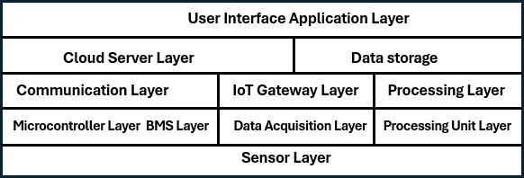

Fig 9 : Designed 5 Layered Architecture.

The proposed IoT architecture for battery charging management consists of five distinct layers, each playing a crucial role in optimizing the efficiency and effectiveness of electric vehicle (EV) charging operations.

User Interface Application Layer
This layer provides the front-end interface through which users interact with the charging system. It includes mobile applications and web platforms that allow users to monitor and manage their charging sessions in real-time.
A user can access a mobile app to find nearby charging stations, view their availability, and start or stop charging remotely. The app can also provide notifications about charging status, estimated time to completion, and energy consumption metrics.

Cloud Server and Data Storage
The cloud server acts as the central hub for data storage and analytics. It collects data from various sources, processes it, and stores it for future analysis. This layer enables predictive analytics, which helps in forecasting energy needs and optimizing charging schedules.
Data from multiple charging stations is aggregated in the cloud, where algorithms analyze usage patterns to predict peak demand times. This information can be used to adjust pricing strategies or manage energy distribution more effectively.

Communication Layer
This layer facilitates seamless connectivity between devices, sensors, and the cloud server using IoT gateways. It ensures that data is transmitted in real-time, allowing for effective monitoring and control of the entire system.
IoT gateways connect solar panels, ESS units, and charging stations to the cloud server. When a vehicle is plugged into a charger, the gateway transmits data about the vehicle's battery state and current energy availability to the cloud for processing.

Microcontroller Layer
The microcontroller layer includes Battery Management Systems (BMS) that process real-time data from sensors deployed throughout the charging infrastructure. This layer manages critical parameters such as voltage levels, temperature readings, and state-of-charge (SOC) of batteries.
A microcontroller monitors the temperature of battery packs during charging to prevent overheating. If temperatures exceed safe limits, it can automatically reduce the charging current or shut down the charger until conditions are safe.

Sensor Layer
The sensor layer consists of various sensors that collect critical data regarding environmental conditions and operational metrics. These sensors provide real-time information essential for managing charging operations effectively.
Sensors measure solar irradiance levels to determine how much solar power is available for charging. Additionally, current sensors monitor the flow of electricity during charging sessions to ensure that it remains within safe operational limits.

Integration of Layers

The integration of these layers creates a cohesive system capable of optimizing EV charging operations by leveraging real-time data monitoring and predictive analytics.
When solar energy generation is high, the system prioritizes solar power for charging.

If solar generation drops or demand increases beyond what solar can supply, the ESS activates to provide additional power. Grid power serves as a backup when both solar and ESS cannot meet demand.

Proposed Flow
    - End to End power flow
This flowchart outlines the logic for managing the charging of batteries in a system that integrates multiple power sources: solar, energy storage systems (ESS), and the grid. The system aims to optimize battery charging by prioritizing renewable energy sources and utilizing the grid when necessary.
Start: The process begins with a check for available power sources.

Solar: If solar power is available, it is used to charge the battery.

ESS: If the ESS is available and not fully charged, it is charged.

Grid: If neither solar nor ESS is available, the grid is used for charging.

Charging Scenarios:

Solar ON, ESS Charge: If solar power is available and the ESS is not fully charged, solar power is used to charge the ESS, and the grid is turned off.
Solar ON, ESS > 80%: If solar power is available and the ESS is more than 80% charged, solar power is used to power the load directly, and the grid is turned on to provide backup power.
Solar OFF, ESS ON: If solar power is not available and the ESS has sufficient charge, the ESS is used to power the load.
Solar OFF, ESS < 20%: If solar power is not available and the ESS is less than 20% charged, the grid is used to power the load.

Output loads:

Battery Swapping Station: The system can support battery swapping stations by providing charged batteries.
DC Fast Charging Station: The system can enable DC fast charging of electric vehicles.

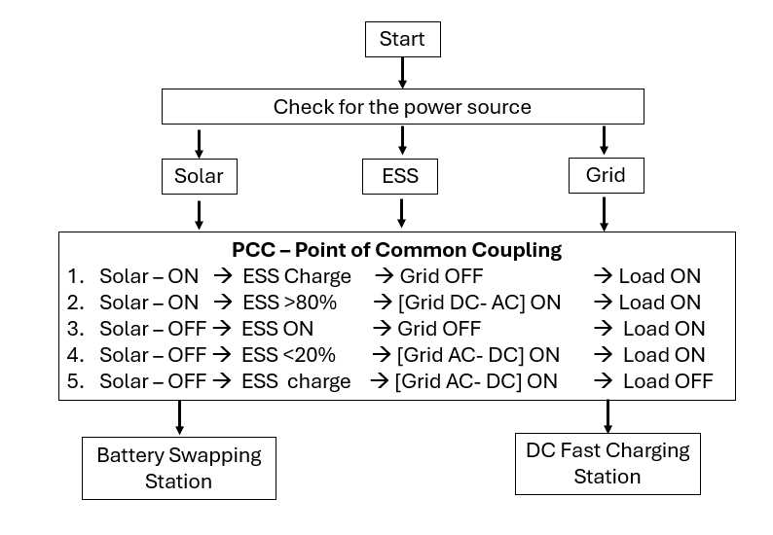

Fig 10 : PCC Control Flow

PCC Integration and Automation
This flowchart outlines the logic for integrating a Point of Common Coupling (PCC) with various power sources (solar, ESS, and grid) to optimize energy flow and manage battery charging.
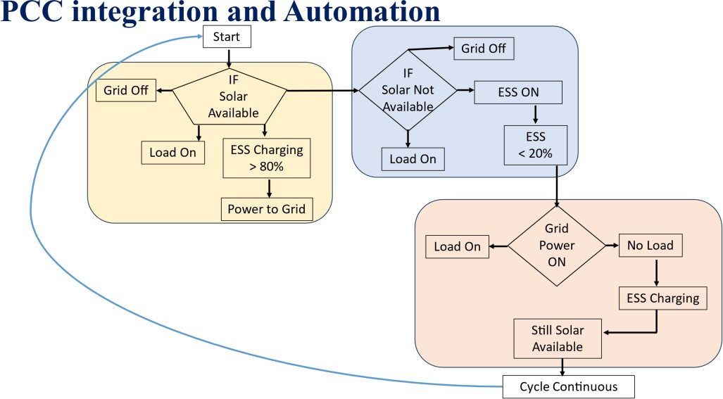

Fig 11 : PPC integration and Automation

Solar Available: If solar power is available, the ESS is charged to 80%. Once charged, excess solar power is fed back to the grid.
Solar Not Available: If solar power is not available, the ESS is used to power the load if it is above 20% charged. If the ESS is below 20%, grid power is used to power the load.
Grid Power ON: If grid power is available, it is used to power the load.

Grid Power OFF: If grid power is not available, the ESS is used to power the load if it is above 20% charged. If the ESS is below 20%, no load is powered.
Cycle Continuous: The process continues in a loop, checking for solar availability and adjusting power flow accordingly.

Algorithms
The demand for electric vehicles (EVs) continues to rise, the need for efficient and robust charging infrastructure has become increasingly critical. This documentation outlines the algorithms employed within the proposed Internet of Things (IoT) architecture for battery charging management, which integrates renewable energy sources such as solar power and Energy Storage Systems (ESS) with grid electricity. The algorithms are designed to optimize charging operations, enhance battery management, and improve overall efficiency.

State of Charge (SOC) Calculation Algorithm:

The SOC algorithm calculates the current state of charge of the battery based on voltage readings and predefined thresholds. It ensures that the SOC remains within acceptable limits to prevent overcharging or deep discharging, which can damage battery health.

Charging and Discharging Control Algorithm:

This algorithm manages when to charge or discharge the battery based on its SOC. If the SOC is above a certain threshold (e.g., 80%), the system will prioritize load operation while disabling charging. Conversely, if SOC falls below a specified level (e.g., 40%), the system will turn off loads and initiate charging.

Maximum Power Point Tracking (MPPT) Algorithm:

The MPPT algorithm optimizes the power output from solar panels by continuously adjusting the duty cycle based on real-time voltage and current measurements. This ensures that maximum energy is harvested from solar resources under varying environmental conditions.

Data Monitoring and Predictive Analytics Algorithm:

This algorithm collects real-time data from various sensors monitoring parameters such as voltage, current, temperature, and insulation resistance. It utilizes predictive analytics to forecast energy needs, allowing for proactive management of charging schedules and resource allocation.

Energy Source Management Algorithm:

This algorithm determines the optimal use of available energy sources—solar, ESS, or grid power— based on real-time conditions. It prioritizes solar energy first, utilizes stored energy from ESS when solar generation is insufficient, and resorts to grid power only when necessary.
The proposed project outlines an Internet of Things (IoT) architecture for battery charging management, addressing the growing demand for efficient electric vehicle (EV) charging infrastructure. This architecture integrates renewable energy sources, such as solar power and energy storage systems (ESS), with grid electricity to optimize charging operations. It consists of five distinct layers: User Interface Application Layer, Cloud Server and Data Storage, Communication Layer, Microcontroller Layer, and Sensor Layer. By leveraging real-time data monitoring and predictive analytics, the system aims to enhance battery management and improve overall efficiency in EV charging operations, achieving significant cost reductions—up to 90%—through optimized resource utilization. The methodology emphasizes a layered design that facilitates mobile and web access for users, while integrating multiple energy sources at the Point of Common Coupling (PCC). This approach not only addresses compatibility issues and the economic viability of vehicle-to-grid technology but also aligns with market demands driven by increasing EV sales and consumer preferences for renewable energy solutions. The future scope includes optimizing operational costs, improving customer engagement through real-time information, and enabling scalable infrastructure to adapt to changing market conditions. Ultimately, this IoT architecture promotes sustainable practices in the transportation ecosystem by maximizing the use of renewable energy sources.

Solar MPPT
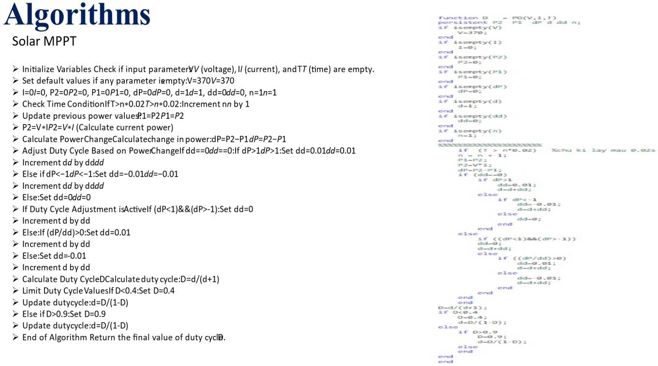
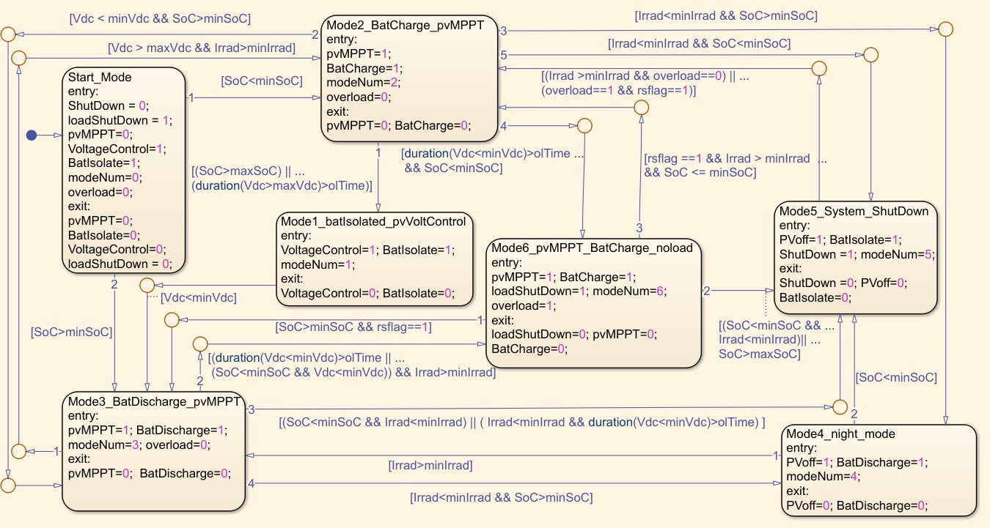

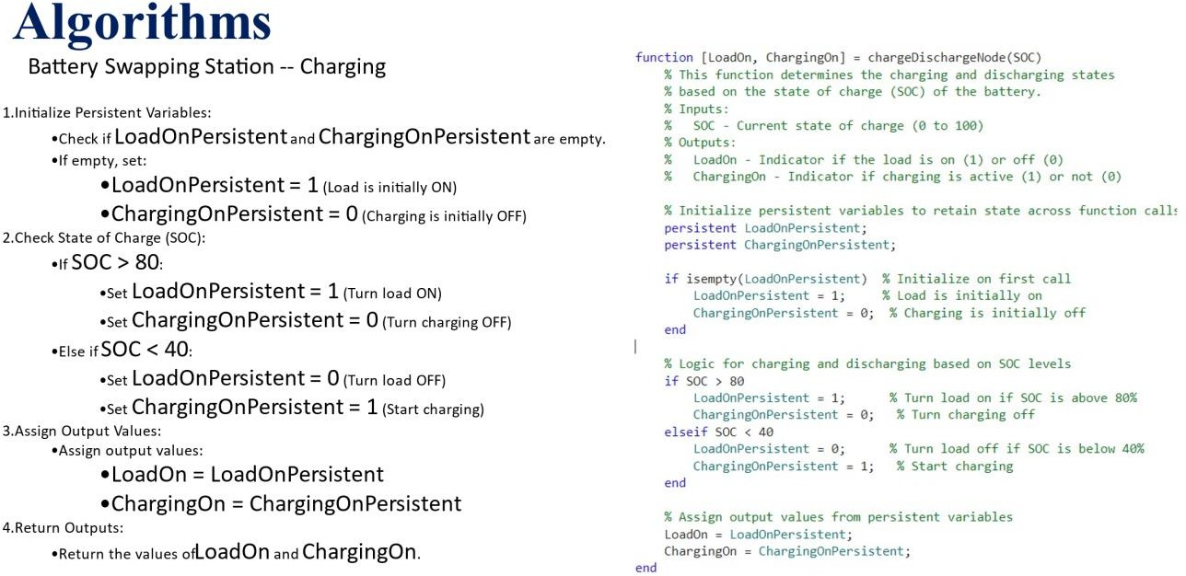

Vehicle Charging control calculation
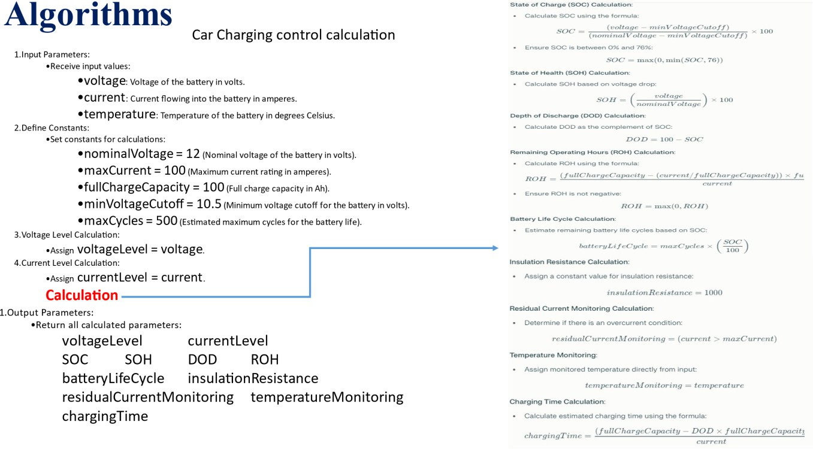

Chapter – 5
Software Simulations and Tools

MATLAB
MATLAB is a powerful computational tool widely used for modeling, simulation, and analysis in engineering and scientific applications. In the context of the proposed battery charging management system, MATLAB serves as an essential platform for simulating the integrated IoT architecture that combines solar power, Energy Storage Systems (ESS), and grid electricity. By utilizing MATLAB's robust simulation capabilities, the project aims to reduce hardware costs and facilitate modifications before actual implementation.
Reproduced from https://images.app.goo.gl/KzNMaYqH4prCcXsx9

Fig 12 : MATLAB Tool

One of the primary advantages of using MATLAB is its ability to create detailed models of complex systems. The software allows for the simulation of various components within the battery charging management system, including the Maximum Power Point Tracking (MPPT) algorithms, charging and discharging control strategies, and real-time data monitoring processes. This capability enables researchers and engineers to analyze system performance under different scenarios without the need for physical prototypes.
MATLAB also provides a user-friendly interface for visualizing data and results, making it easier to interpret simulation outcomes. Users can generate plots and graphs to illustrate key parameters such as State of Charge (SOC), State of Health (SOH), voltage levels, and current levels over time. This visual feedback is crucial for understanding how different variables interact within the system and for optimizing control algorithms.

Furthermore, MATLAB's extensive libraries and toolboxes, such as Simulink, facilitate the development of dynamic simulations that can model real-world behavior accurately. By incorporating various environmental factors—such as temperature fluctuations and varying sunlight intensity—into the simulations, developers can ensure that the proposed system is robust and capable of adapting to changing conditions.

NODE- RED
Node-RED is a powerful open-source flow-based development tool designed for visual programming, particularly in the context of Internet of Things (IoT) applications. It provides a user- friendly interface that allows developers to wire together devices, APIs, and online services through a web-based flow editor. This capability makes Node-RED an ideal choice for data visualization and control in complex systems such as battery charging management.

Reproduced from https://images.app.goo.gl/KKed14R2DPn2ekJW6
Fig 13 : Node-Red Tool

One of the primary advantages of using Node-RED is its ability to facilitate real-time data monitoring and visualization. Users can create custom dashboards that display key metrics related to battery performance, such as voltage levels, current flow, State of Charge (SOC), and temperature readings. This visual representation of data enables operators to quickly assess system performance and make informed decisions based on real-time information.
Node-RED also supports the integration of various data sources and protocols, making it versatile for diverse IoT applications. It can connect with MQTT, HTTP, WebSocket, and other communication protocols, allowing seamless interaction between different components of the battery charging management system. This flexibility is crucial for managing multiple energy sources—solar power, Energy Storage Systems (ESS), and grid electricity—ensuring that data flows efficiently between them.

In addition to visualization, Node-RED provides control capabilities that enable users to automate processes within the charging management system. For example, based on predefined conditions such as SOC thresholds or environmental factors, Node-RED can trigger actions like starting or stopping charging processes or adjusting load levels. This automation enhances operational efficiency and reduces the need for manual intervention.
The Node-RED's extensive library of pre-built nodes allows for rapid development and prototyping. Users can easily incorporate functionalities such as data logging, alert notifications, and integration with cloud services into their projects without extensive coding knowledge. This accessibility accelerates the development cycle and allows for quick iterations based on testing and feedback.

AWS – Amazon Web Services
Amazon Web Services (AWS) provides a comprehensive suite of cloud computing services that are instrumental in enhancing the functionality and scalability of the battery charging management system. In this project, AWS is utilized primarily for data storage, alert notifications, and visualization, leveraging services such as Amazon S3, Amazon QuickSight, and the MQTT protocol.

Reproduced from https://images.app.goo.gl/y7SKEecxn8mzkiwj8
Fig 14 : AWS Tool

Data Storage with Amazon S3

Amazon Simple Storage Service (S3) is a highly scalable object storage service that allows for secure and durable storage of data. In the context of the battery charging management system, data collected from various sensors—such as voltage levels, current measurements, temperature readings, and State of Charge (SOC)—is stored in S3 buckets. This centralized data storage enables easy access and retrieval of historical data for analysis and reporting.

The use of S3 also ensures that data is backed up and protected against loss, providing a reliable solution for long-term data retention. The flexibility of S3 allows users to store vast amounts of data without worrying about capacity limits, making it ideal for IoT applications where data generation can be substantial.

Email Alerts

AWS provides robust notification services through Amazon Simple Notification Service (SNS), which can be integrated with the battery charging management system to send email alerts based on predefined conditions. For instance, if the SOC falls below a certain threshold or if an overcurrent condition is detected, SNS can automatically trigger an email alert to notify system operators or users. This proactive approach enhances operational awareness and allows for timely interventions to prevent potential issues.

Data Visualization with Amazon QuickSight

Amazon QuickSight is a business intelligence service that enables users to create interactive dashboards and visualizations from their data stored in S3. By integrating QuickSight into the battery charging management system, stakeholders can gain insights into system performance through visually appealing charts and graphs.
Users can build custom dashboards that display key performance indicators (KPIs), such as energy production from solar panels, charging efficiency, historical trends in SOC, and operational metrics. The ability to visualize this data in real-time aids in decision-making processes and helps identify patterns or anomalies in system behavior.

MQTT Protocol Integration

The Message Queuing Telemetry Transport (MQTT) protocol is a lightweight messaging protocol designed for low-bandwidth and high-latency networks, making it ideal for IoT applications. In this project, MQTT facilitates communication between various components of the battery charging management system and AWS services.

By using MQTT, real-time data from sensors can be transmitted efficiently to AWS for processing and storage. This protocol supports the publish-subscribe model, allowing different devices to communicate seamlessly without direct connections. This flexibility enhances the scalability of the system as new devices or sensors can be added easily without significant reconfiguration.
The combination of MATLAB for simulation, Node-RED for data visualization and control, and AWS for data storage and analytics creates a comprehensive framework for managing battery charging in electric vehicles. These tools work together to optimize operational efficiency, enhance user experience, and promote sustainable practices through effective utilization of renewable energy sources. By leveraging these technologies, the proposed IoT architecture not only addresses current challenges in EV charging infrastructure but also positions itself for future scalability and innovation in energy management solutions.

Chapter – 6
Design Simulation and Results

Design Simulation Battery charging Technology and Power Integration
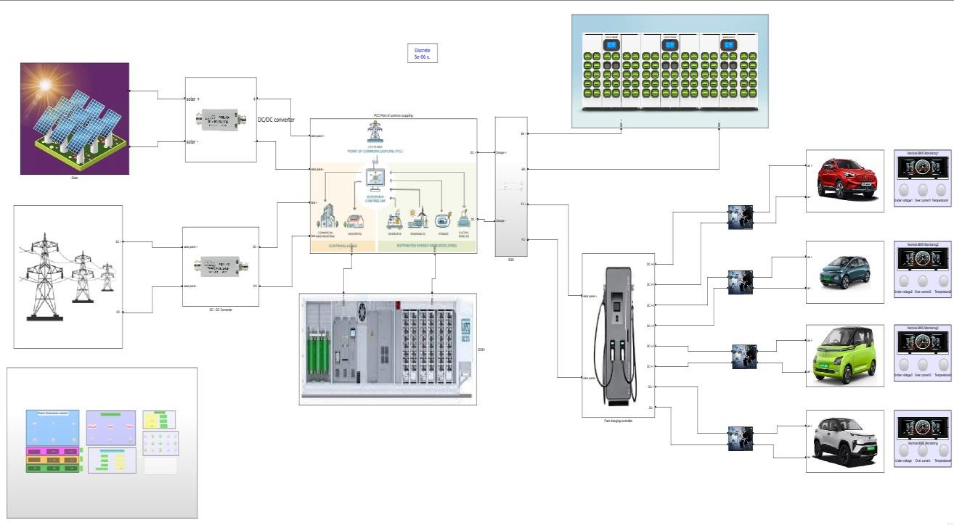
Fig 15 : Simulation of Battery charging Technology and Power Integration
The MATLAB simulation for the proposed battery charging management system integrates solar energy, Energy Storage Systems (ESS), and grid power at the Point of Common Coupling (PCC). This innovative architecture is designed to optimize the charging process for electric vehicles (EVs) while ensuring efficient utilization of available energy resources. By connecting these three energy sources, the system can dynamically manage energy flows based on real-time conditions, prioritizing solar power first, followed by stored energy from the ESS, and utilizing grid electricity as a backup when necessary.
At the PCC, the simulation also connects battery swapping stations and fast charging units, allowing for flexible and efficient energy distribution to meet varying demand levels. The integration of these components enables the system to adapt to fluctuations in energy production and consumption effectively. Each parameter related to battery performance—such as voltage, current, State of Charge (SOC), and temperature—is continuously monitored through an Internet of Things (IoT) architecture. This real-time data collection facilitates proactive management of charging operations and ensures optimal battery health.

The proposed IoT architecture consists of five distinct layers: User Interface Application Layer, Cloud Server and Data Storage, Communication Layer, Microcontroller Layer, and Sensor Layer. This layered approach allows for centralized monitoring and control, enabling users to track charging status and energy consumption easily. Additionally, predictive analytics within the cloud server help
forecast power demand and optimize charging schedules based on historical data and current usage patterns.
Preliminary simulations indicate a significant reduction in operational costs—up to 90%—through optimized resource utilization. The integration of renewable energy sources not only enhances sustainability but also addresses the growing demand for efficient EV charging infrastructure. By leveraging MATLAB simulations to model this complex system before physical implementation, the project aims to refine its design and ensure its effectiveness in real-world applications.

Solar Generation Unit
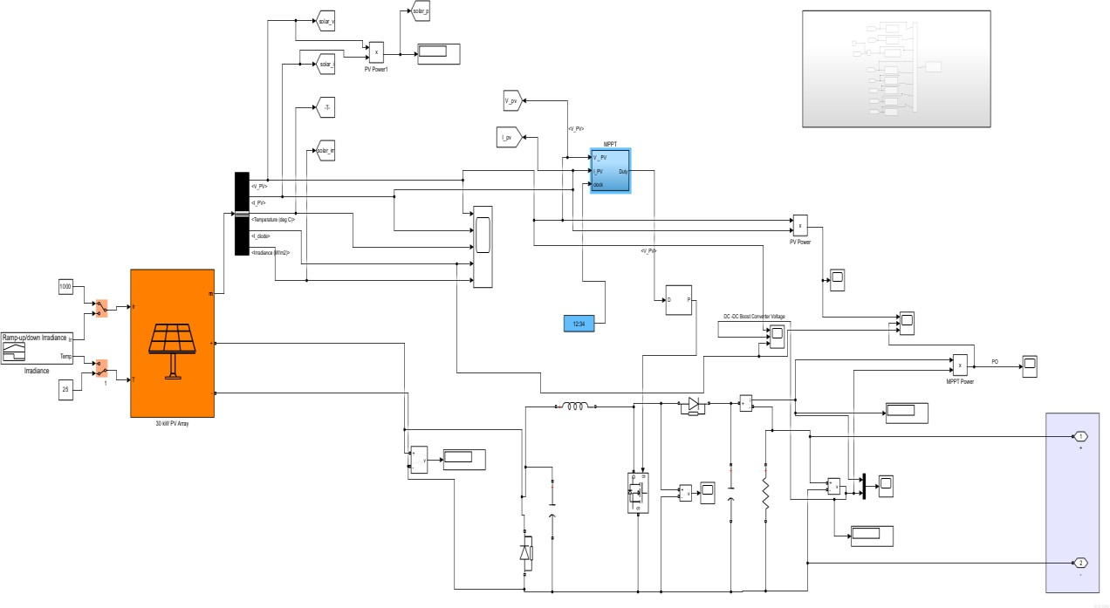

Fig 16 : Solar generation unit

The solar generation unit in this project is designed with a capacity of 30 kW, making it a significant contributor to the overall energy management system. This submodule operates efficiently by generating approximately 60% of its rated solar power, which translates to a practical output under optimal conditions. Specifically, the system produces a voltage of 212 V and a current of 120 A, resulting in a power output of 26 watts during standard operating conditions.

To enhance the energy output and adapt to the requirements of the battery charging management system, the solar generation unit is connected to a DC Boost Converter. This converter plays a critical role in stepping up the voltage from the solar panels. After processing through the boost converter, the output is increased to 430 V with a current of 94 A, yielding an effective power output of 40 watts. This conversion is essential for ensuring that the energy produced can be efficiently utilized for charging batteries or feeding into the grid.
The integration of this solar generation submodule into the overall IoT architecture allows for real- time monitoring and optimization of energy production. By leveraging advanced data analytics, the
system can dynamically adjust operations based on solar availability, battery state of charge, and overall energy demand. This capability not only enhances the efficiency of the charging process but also contributes to sustainability by maximizing the use of renewable energy sources.
This solar generation unit, with its 30-kW capacity and effective integration with a DC Boost Converter, plays a pivotal role in supporting the project's goals of efficient battery charging management and promoting renewable energy utilization within the framework of an IoT-enabled infrastructure.

Grid Generation Unit
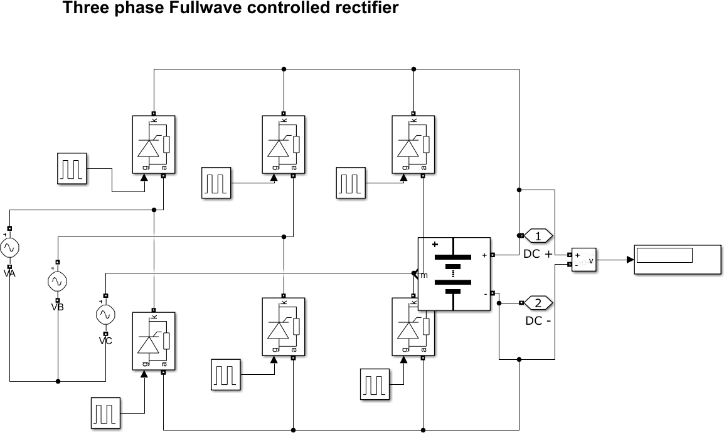
The integration of the grid unit into the battery charging management system is a critical component that enhances the overall efficiency and reliability of the energy supply for electric vehicle (EV) charging. In this project, the grid unit is designed to operate at an output voltage of 430 V, with a current capacity of 177 A, resulting in a power output of 51 watts. This configuration allows the system to effectively manage energy demands by providing a stable power source when solar generation and energy storage are insufficient.

Fig 17 : Grid Generation unit

The grid unit serves as a backup power source, ensuring that charging operations can continue uninterrupted during periods of low solar energy generation or when the Energy Storage System (ESS) is depleted. This capability is essential for maintaining service availability, particularly in scenarios where EV charging demand peaks.
By integrating the grid unit at the Point of Common Coupling (PCC), the system can balance loads effectively between solar power, ESS, and grid electricity. This load management ensures optimal resource utilization, reducing reliance on any single energy source and enhancing overall system resilience. The grid unit allows for dynamic adjustments based on real-time data analytics. When solar generation is high, the system prioritizes solar energy for charging; however, if solar output drops below a certain threshold, the grid unit can automatically supplement power to maintain consistent charging operations.
The integration of the grid unit facilitates comprehensive monitoring and control capabilities within the IoT architecture. The system continuously tracks key parameters such as voltage, current, and overall power output from the grid, allowing for proactive management and timely interventions if anomalies are detected. The grid unit’s integration supports advanced smart charging solutions that can optimize energy costs based on real-time electricity pricing. This feature enables users to take advantage of lower rates during off-peak hours, further enhancing cost efficiency.
The integration of the grid unit into the battery charging management system plays a vital role in ensuring reliable and efficient EV charging operations. By providing a stable power source with an output of 430 V and 177 A, it enhances load balancing, supports dynamic energy management, and facilitates comprehensive monitoring within the IoT architecture. This integration not only improves operational efficiency but also contributes to a more sustainable energy ecosystem by optimizing the use of renewable resources alongside traditional grid power.

ESS Energy Storage system
The Energy Storage System (ESS) in this project is designed to significantly enhance the efficiency and reliability of the battery charging management system by utilizing 40 lead-acid batteries, each with a capacity of 12V and 100Ah. This configuration results in a total power bank capable of supplying 480V at a current of 140A, yielding an overall power output of 68 watts. The integration of this ESS is crucial for managing energy supply effectively, particularly in scenarios where solar generation is insufficient or during peak demand periods for electric vehicle (EV) charging.

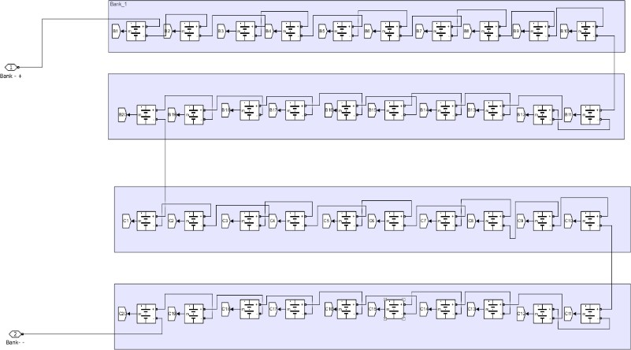
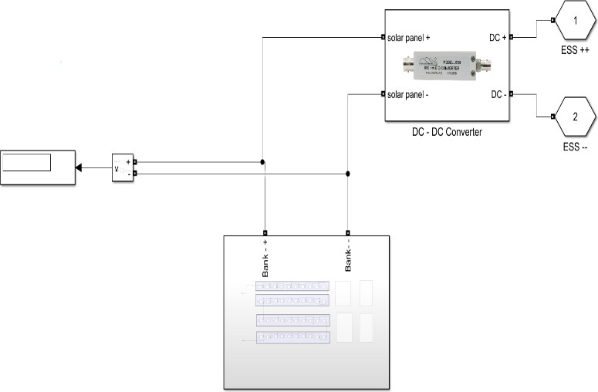

Fig 18 : BESS Battery Energy Storage System

The ESS acts as a buffer that stores excess energy generated from solar panels during peak sunlight hours. This stored energy can then be utilized when solar generation is low or when demand exceeds the available solar output, ensuring a continuous power supply for EV charging.
By integrating the ESS at the Point of Common Coupling (PCC), the system can efficiently manage loads between solar power, grid electricity, and stored energy. This load balancing capability allows for optimal resource utilization, reducing reliance on any single energy source and enhancing overall system resilience.
The ESS improves charging efficiency by providing a stable voltage and current output to the battery swapping stations and fast charging units. This stability is essential for maintaining battery health and ensuring quick charging times for EVs. The ESS is equipped with monitoring capabilities that track key parameters such as State of Charge (SOC), voltage, and temperature. This real-time data is integrated into IoT architecture, allowing for proactive management of charging operations and timely interventions if any anomalies are detected.
By maximizing the use of renewable energy sources, the ESS contributes to the sustainability goals of the project. It enables the system to reduce its carbon footprint by relying more on solar energy while ensuring that energy demands are met efficiently.

The integration of the Energy Storage System (ESS) comprising 40 lead-acid batteries into the battery charging management system plays a vital role in enhancing operational efficiency and reliability. With a capacity to supply 480V at 140A, this ESS not only buffers energy but also facilitates load management and improves charging efficiency. By leveraging real-time monitoring within an IoT framework, the system ensures optimal performance while promoting sustainable practices through effective utilization of renewable energy sources. This comprehensive approach positions the project as a forward-thinking solution in the rapidly evolving landscape of electric vehicle infrastructure.

PCC – Point of common coupling and Power Source Integration and Automation
Automation Logic for Point of Common Coupling (PCC)

The automation logic for the Point of Common Coupling (PCC) in the battery charging management system is designed to optimize energy flow from solar power, Energy Storage Systems (ESS), and grid electricity based on real-time conditions.

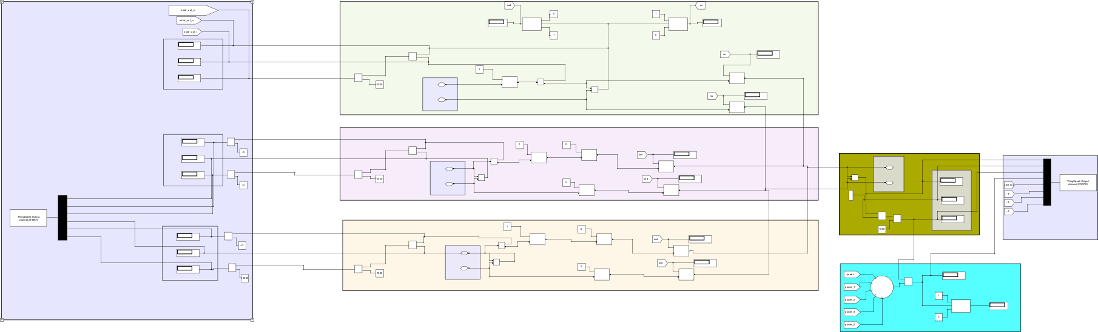

Fig 19 : PCC Point of Coming Coupling
The following conditions outline the operational states and corresponding actions for efficient energy management:

Solar ON → ESS Charge → Grid OFF → Load ON:

When solar energy is available, the system prioritizes charging the ESS using the generated solar power.The grid connection is turned off to maximize the use of renewable energy.
The load (e.g., EV charging stations) is activated to utilize the available solar energy, ensuring efficient energy consumption.

Solar ON → ESS > 80% → [Grid DC-AC] ON → Load ON:

If solar generation is active and the State of Charge (SOC) of the ESS exceeds 80%, the system allows for grid connection.
The grid is converted from DC to AC to support additional loads or provide power to the grid if necessary.
The load remains on, benefiting from both solar and grid power to meet demand.

Solar OFF → ESS ON → Grid OFF → Load ON:

In scenarios where solar generation is not available, but the ESS has sufficient charge, the system will utilize stored energy from the ESS.
The grid remains disconnected to ensure that all energy supplied to the load comes from the ESS. This configuration maintains continuous operation of loads even in the absence of solar power.

Solar OFF → ESS < 20% → [Grid DC-AC] ON → Load ON:

If solar generation is absent and the SOC of the ESS falls below 20%, indicating low stored energy, the system activates the grid connection.
The grid is converted from DC to AC to provide necessary power to maintain load operations.

This ensures that critical loads are powered even when renewable sources are insufficient, preventing service interruptions.
The automation logic for PCC effectively manages energy flows between solar power, ESS, and grid electricity based on real-time conditions. By prioritizing renewable energy usage while ensuring reliable backup power from the grid, this system enhances operational efficiency and sustainability
in electric vehicle charging infrastructure. The integration of these automated controls within an IoT framework allows for real-time monitoring and management, optimizing performance and user experience.

Battery Swapping System
The Battery swapping stations play a crucial role in the evolving landscape of electric vehicle (EV) infrastructure, particularly in enhancing the efficiency and convenience of battery management. The integration of 30 lithium-ion batteries, each rated at 12V and 10A, connected to the Point of Common Coupling (PCC), underscores the significance of these stations in supporting sustainable solutions.
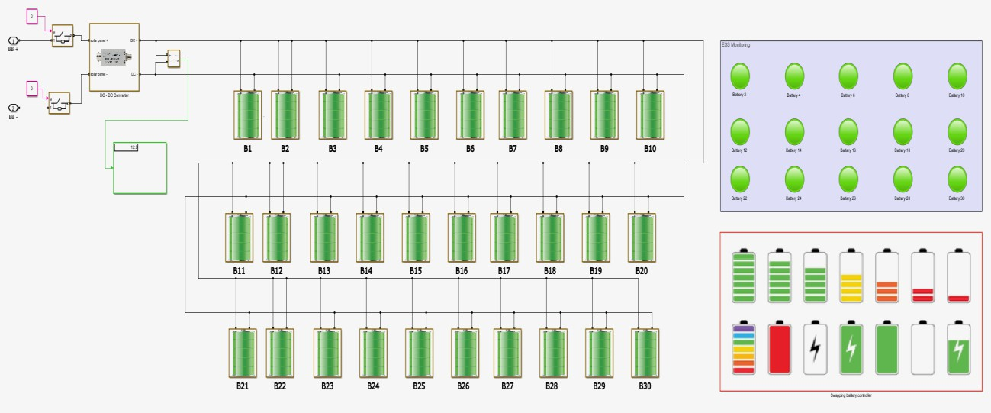
One of the primary advantages of battery swapping stations is their ability to provide quick refueling options for electric vehicles. Unlike traditional charging methods that can take hours, battery swapping allows drivers to replace depleted batteries with fully charged ones in a matter of minutes. This significantly reduces downtime and enhances the overall user experience.
Fig 20 : Battery Swapping Station

Increased Range and Flexibility: By utilizing battery swapping technology, EV users can extend their driving range without the anxiety associated with long charging times. This flexibility is particularly beneficial for commercial fleets and ride-sharing services that require quick turnaround times to maximize operational efficiency.
The integration of lithium-ion batteries in swapping stations allows for centralized battery management, which can improve battery health and longevity. The system can monitor the State of Charge (SOC), temperature, and overall performance of each battery, ensuring that only batteries in optimal condition are deployed to vehicles. This proactive approach helps maintain high performance across the fleet.
Battery swapping stations can be strategically located near renewable energy sources, such as solar power systems integrated at the PCC. This setup allows for efficient energy management, where excess solar energy can be stored in swapped batteries during peak generation times, promoting sustainability and reducing reliance on grid power.
The data collected from battery swapping operations can be analyzed to optimize charging schedules and energy distribution. By integrating with IoT technologies, these stations can dynamically adjust operations based on real-time demand and energy availability, further enhancing operational efficiency. As the demand for electric vehicles continues to grow, battery swapping stations offer a scalable solution that can adapt to changing market conditions. They can be easily expanded or modified to accommodate more batteries or integrate with additional energy sources, ensuring that the infrastructure keeps pace with technological advancements and consumer needs.

DC Fast Charging
The DC fast charging stations are a pivotal component in the infrastructure supporting electric vehicles (EVs), addressing the growing need for quick and efficient charging solutions. These stations utilize direct current (DC) to deliver high power levels, significantly reducing charging times compared to traditional AC charging methods. The integration of DC fast charging stations within the proposed IoT architecture for battery charging management enhances overall efficiency and user experience in EV operations.
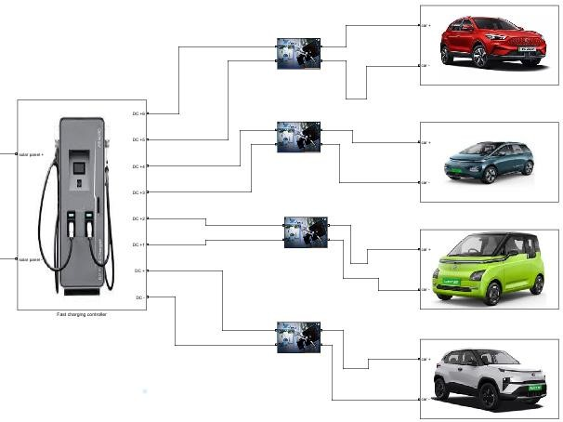
Fig 21 : DC Fast Charging Station

One of the primary advantages of DC fast charging stations is their ability to charge EV batteries quickly, often reaching 80% charge in as little as 30 minutes. This rapid refueling capability is essential for users who require quick turnaround times, such as fleet operators and long-distance travelers. By providing fast charging options, these stations alleviate range anxiety among EV users, allowing them to travel longer distances without the fear of running out of power. This convenience encourages more consumers to adopt electric vehicles, contributing to a sustainable transportation ecosystem.

The proposed system integrates DC fast charging stations with renewable energy sources like solar power and Energy Storage Systems (ESS). This integration allows for efficient energy management, where excess solar energy can be utilized for fast charging, promoting sustainability and reducing reliance on grid electricity.

The DC fast charging stations are designed to handle higher power levels, making them suitable for commercial applications and public charging networks. By accommodating multiple vehicles simultaneously, these stations can support high demand in urban areas and along major travel routes. With in the IoT architecture, DC fast charging stations are equipped with monitoring capabilities that track key parameters such as voltage, current, and State of Charge (SOC).
This data is transmitted to the cloud for analysis, enabling predictive maintenance and optimizing charging schedules based on real-time demand. The modular design of DC fast charging stations allows for easy scalability as the demand for EV charging increases. This flexibility enables
operators to expand their infrastructure quickly, adapting to changing market conditions and consumer needs.

Simulation Monitoring Data.
The MATLAB simulation for the battery charging management system provided a comprehensive platform for monitoring and visualizing critical parameters related to power sources and load operations at the charging station. By integrating various energy sources, including solar power, Energy Storage Systems (ESS), and grid electricity, the simulation enabled real-time data collection and analysis, which are vital for optimizing charging efficiency.
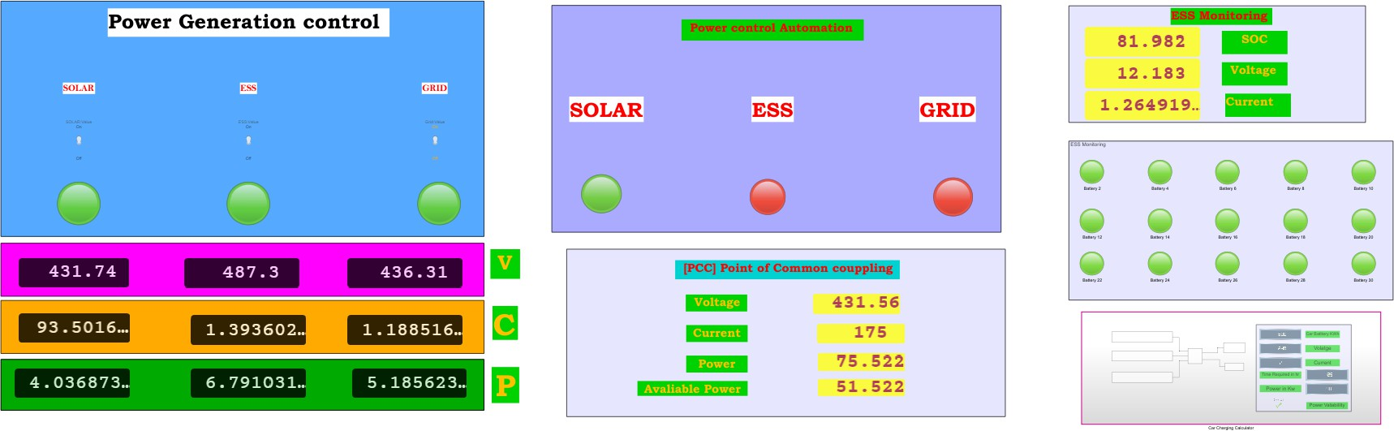

Fig 22: Parameters Data monitoring

Throughout the simulation, key parameters such as voltage, current, State of Charge (SOC), and power output from each energy source were continuously monitored. Visualization tools within MATLAB allowed for the representation of this data in dynamic graphs and charts, facilitating a clear understanding of how different components interact within the system. For instance, the simulation illustrated how solar energy is prioritized during peak generation times, with excess energy directed towards charging the ESS while maintaining load operations for electric vehicles.
The calculated results from the simulation indicated significant improvements in operational efficiency. By effectively managing energy flows and optimizing resource utilization, the system demonstrated potential cost savings of up to 90%. This was achieved through strategic automation of charging schedules based on real-time demand and predictive analytics that forecast energy needs.
The visualization results highlighted the performance metrics of the battery swapping stations and DC fast charging units, showcasing their responsiveness to varying energy availability. The integration of these features within an IoT framework not only enhances user experience by providing real-time insights into charging status but also supports sustainable practices by maximizing the use of renewable energy sources.

Node Red
The integration of MATLAB with ThingSpeak and Node-RED forms a critical component of the proposed IoT architecture for battery charging management, facilitating real-time data monitoring, analysis, and visualization. In this setup, MATLAB serves as the primary platform for collecting and processing data from various parameters related to power sources and load operations at the charging station. This includes key metrics such as voltage, current, State of Charge (SOC), and overall power output from solar panels, Energy Storage Systems (ESS), and grid electricity.
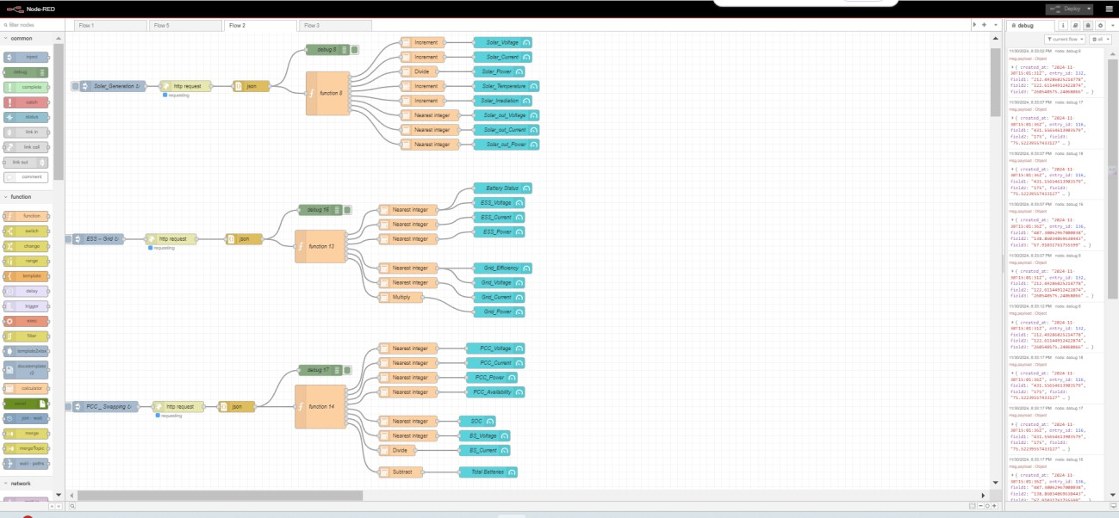
Fig 23 : Node-Red Data mapping and monitoring

Once the data is generated in MATLAB, it is sent to ThingSpeak, a cloud-based IoT analytics platform that allows for the storage and analysis of time-series data. ThingSpeak provides a robust environment for aggregating data from multiple sources, enabling users to visualize trends and patterns over time.

This capability is essential for monitoring the performance of the battery charging management system, as it allows stakeholders to assess how effectively energy resources are being utilized.
Following the data upload to ThingSpeak, the information is then transmitted to Node-RED, a flow- based programming tool that facilitates the customization and visualization of data for various actions. In Node-RED, users can create custom dashboards that display real-time information on charging status, energy consumption, and other critical parameters. This visual representation enhances user engagement by providing intuitive access to system performance metrics. Additionally, Node-RED enables automation of specific actions based on predefined conditions; for example, it can trigger alerts when SOC levels drop below a certain threshold or when energy production from solar panels exceeds expectations.
The seamless flow of data from MATLAB to ThingSpeak and then to Node-RED exemplifies an effective IoT architecture that enhances operational efficiency in battery charging management. By leveraging these technologies, the system not only optimizes energy usage but also supports proactive decision-making through real-time analytics. This integration ultimately contributes to a more sustainable transportation ecosystem by maximizing the utilization of renewable energy sources while ensuring reliable service availability for electric vehicle users.
The collaboration between MATLAB, ThingSpeak, and Node-RED within this IoT framework provides a comprehensive solution for monitoring and managing battery charging operations. The ability to visualize and analyze data in real-time empowers users to make informed decisions that enhance efficiency and sustainability in electric vehicle infrastructure. Future developments will focus on refining these integrations further to expand capabilities and improve user experience in managing energy resources effectively.

Solar Visualization
The visualization of solar energy generation allows users to track the amount of energy produced by solar panels in real-time, facilitating effective management of renewable resources. By displaying key metrics such as voltage, current, and power output, users can assess the efficiency of solar energy utilization and make informed decisions about energy distribution.

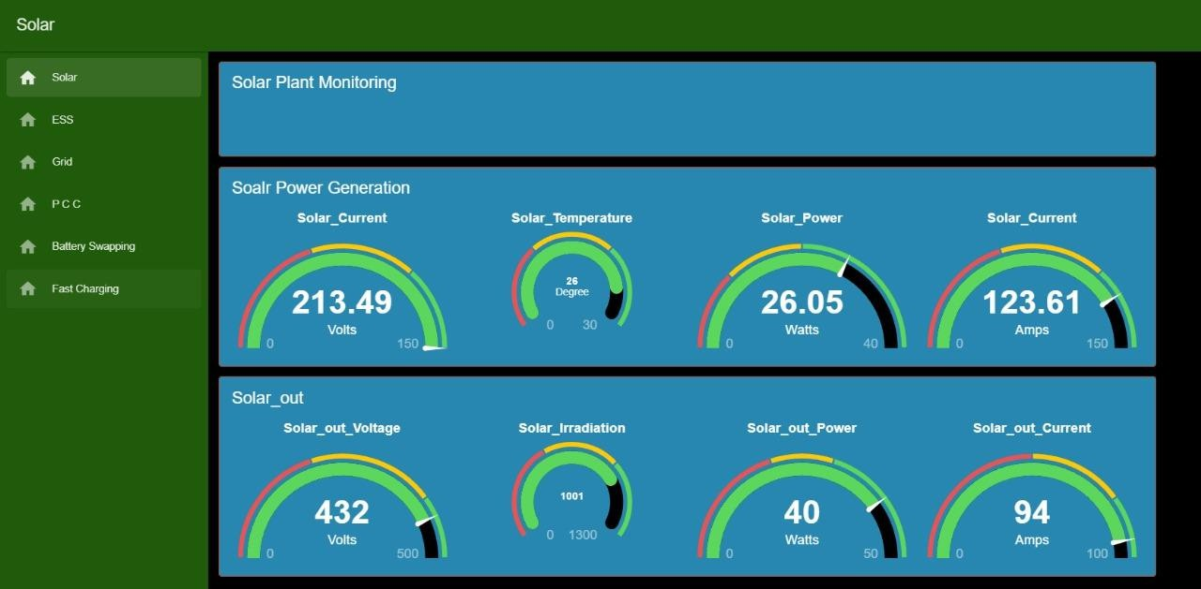
Fig 24 : Solar Data Visualization

ESS Visualization
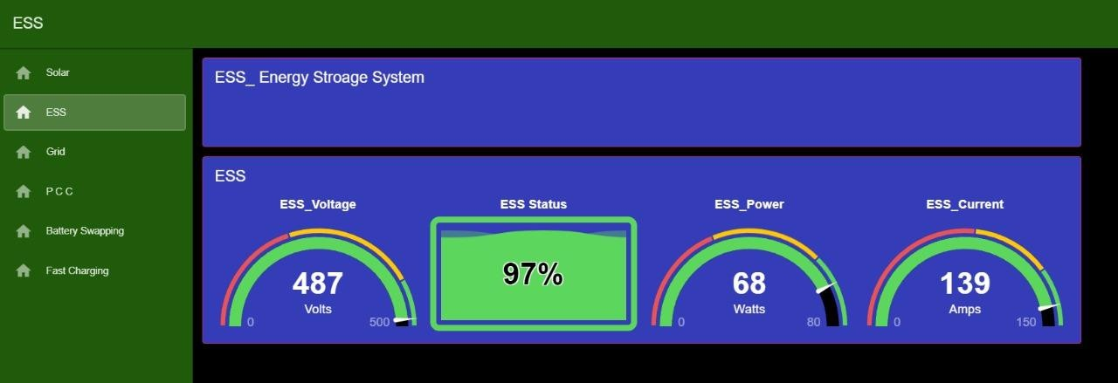
Fig 25 : ESS Visualization

The ESS section of the dashboard provides critical information regarding the state of charge (SOC) of the batteries, enabling users to monitor energy storage levels and optimize charging cycles. This real-time monitoring ensures that the ESS is adequately charged during peak solar production times, allowing for efficient energy use when solar generation is low.

Grid Power Visualization
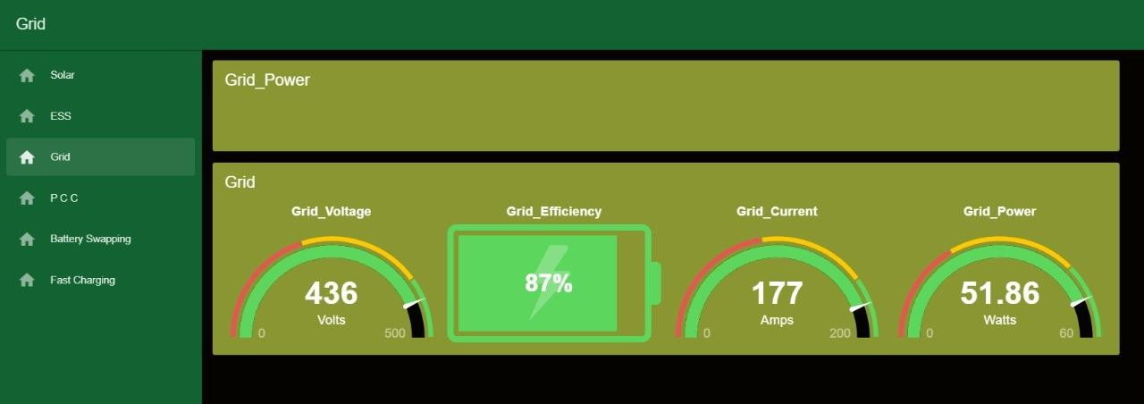
Fig 26 : Grid Power Visualization

Grid power visualization is essential for understanding how much electricity is being drawn from or fed into the grid. This feature supports load management by indicating when to rely on grid power versus stored energy from the ESS or solar generation, thereby optimizing operational costs and enhancing sustainability.

PCC Visualization
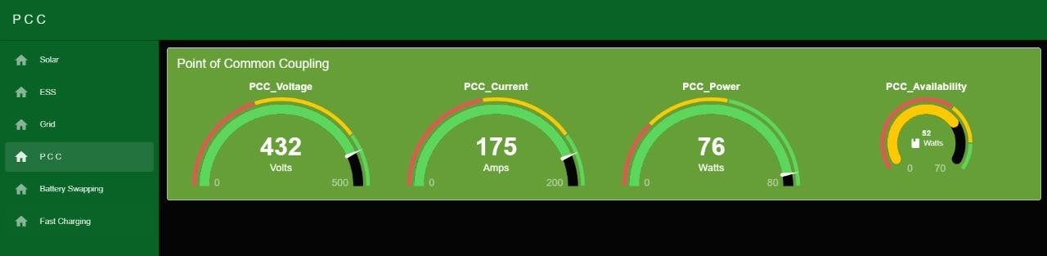
Fig 27 : PCC Visualization

The PCC section integrates data from all connected sources, displaying how energy flows between solar panels, ESS, and grid power. This holistic view enables users to manage loads effectively and ensure that energy is utilized efficiently across all components of the system.

Battery Swapping and Fast charging Station Visualization.
The dashboard includes visual representations for battery swapping stations and fast charging units. Users can monitor the status of available batteries for swapping and track fast charging operations, ensuring that EVs can be serviced quickly and efficiently. This capability enhances user convenience and promotes higher turnover rates at charging stations.
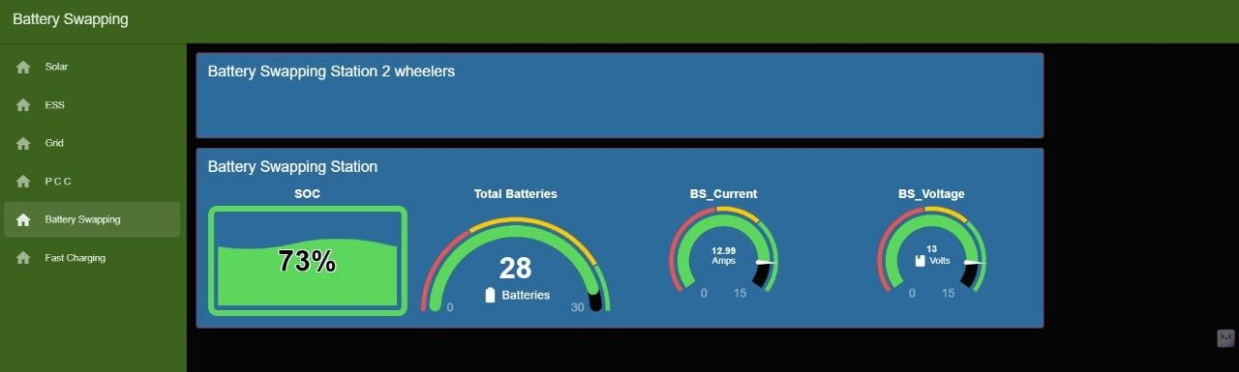

Fig 28 : Battery Swapping Station Visualization
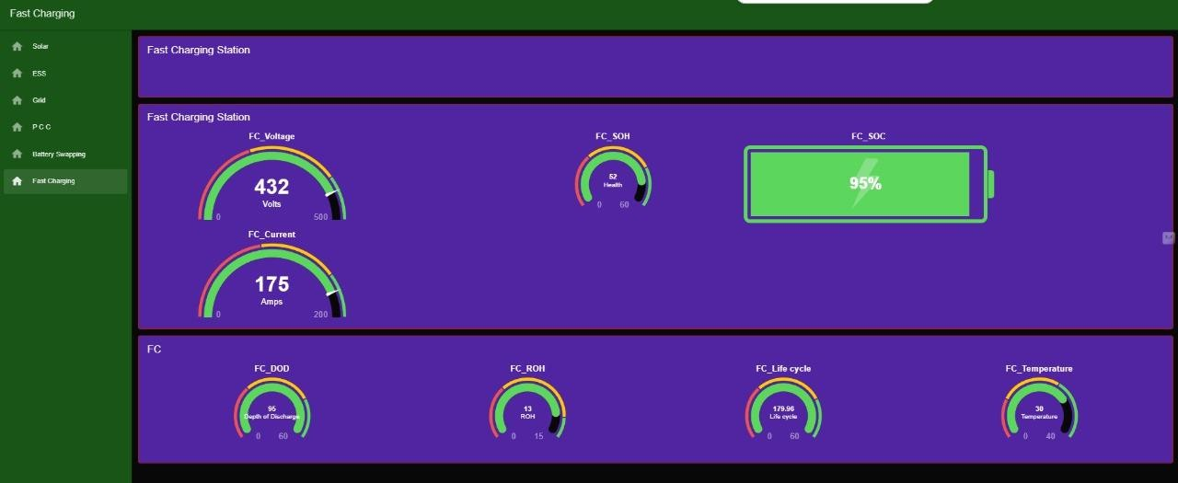

Fig 29 : DC Fast Charging Station Visualization

AWS – Integration
In the proposed battery charging management system, Amazon Web Services (AWS) plays a pivotal role in data storage, notification management, and visualization, enhancing the overall functionality and reliability of the system. By utilizing AWS, the project ensures that critical data collected from various components of the charging infrastructure is securely stored and easily accessible for analysis and reporting.

Data Storage in Amazon S3

Amazon Simple Storage Service (S3) is employed to store vast amounts of data generated by the system, including metrics related to solar energy production, Energy Storage System (ESS) performance, grid power usage, and battery swapping operations. S3 provides a highly scalable and durable storage solution that allows for efficient data management without the constraints of traditional storage systems. This centralized data repository enables easy retrieval and analysis of historical data, facilitating insights into system performance over time.


Fig 30 : Data storage in AWS S3 Bucket

Email Alerts with Amazon SNS

To enhance operational efficiency and ensure proactive management, AWS integrates Amazon Simple Notification Service (SNS) for sending email alerts based on predefined conditions. For instance, if the State of Charge (SOC) of the ESS falls below a certain threshold or if there is an anomaly detected in energy production or consumption, SNS can automatically trigger email notifications to relevant stakeholders. This capability ensures that operators are promptly informed of critical situations, allowing for timely interventions to maintain optimal system performance.


Fig 31 : AWS SNS Email Alerts

Visualization with Amazon QuickSight

AWS also provides powerful visualization capabilities through Amazon QuickSight, a business intelligence service that allows users to create interactive dashboards and visualizations from the data stored in S3. By integrating QuickSight into the battery charging management system, stakeholders can gain valuable insights into key performance indicators (KPIs) such as energy production trends, charging efficiency metrics, and overall operational statistics. Custom dashboards can be designed to display real-time data analytics, enabling users to monitor system performance effectively and make informed decisions based on visualized data.
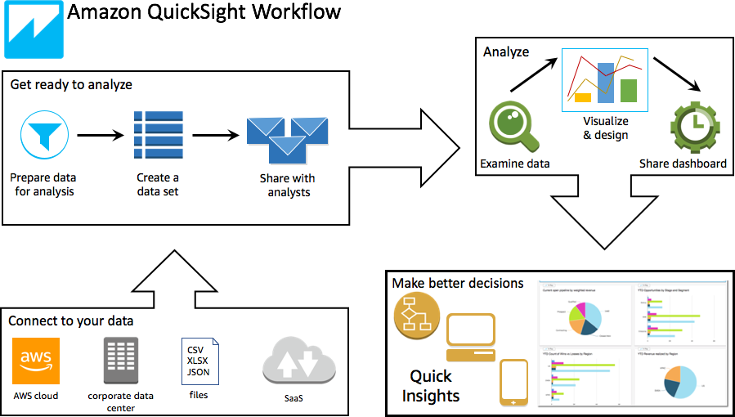
Fig 32 : AWS QuickSlights flow

Estimated Calculation Spread sheet
Fast Charging Station Load
Cars | Voltage (V) | Power (kW) | Battery Capacity (kWh) | SOC Avaliable | Required Current | harging Time in h | Unit charge | Cost
1 - Tata Nexon -  EV | 400 | 30.2 | 30.2 | 20 | 75.5 | 2.47 | 10 | 745.83
2- MG ZS EV | 400 | 50 | 44.5 | 30 | 125 | 1.49 | 10 | 743.75
3-Tata Trigo EV | 400 | 16.8 | 26 | 50 | 42 | 4.40 | 10 | 739.58
4- Mahindra eVerito | 400 | 70 | 60 | 10 | 175 | 1.07 | 10 | 747.92
Total Power |  | 167 |  |  | Total Time | 9 | Total  Revenue | 2977

Total Energy claculation
Power sources | KW / day | KW / Month | KW / year | KW / 5 years
Required full Power From Grid | 1,817 | 54,510 | 663,205 | 3,316,025
Solar | 1,032 | 30,960 | 376,680 | 1,883,400
ESS | 576 | 17,280 | 210,240 | 1,051,200
Grid | 209 | 6,270 | 76,285 | 381,425
Total Power saving / Day | 1,608 | 48,240 | 586,920 | 2,934,600
Total Generation Cost / Day  12rs / unit | 21,804 | 654,120 | 7,958,460 | 39,792,300
Total Generation Cost Saving  / Day 12rs / unit | 19,296 | 578,880 | 7,043,040 | 35,215,200
Spending Amount | 2,508 | 75,240 | 915,420 | 4,577,100

Total Power | 1670 KW power can charge / day | Total Time | / 96 hr | Total  Revenue | 26794

Total Batteries charging / | 90
Cost of charge per batter | 30
Total Amout Per day | 2700

Battery Swapping Station
Total Batteries | 30
Under maintance | 0
Avaliable batteries | 30
Voltage | 12
Current | 10
Time / Battery in hr | 5
No of Cycle per day | 3
Power/Battery - KW | 0.12
Total Station KW | 18
Total Energy Required for Full Swapping Station per Day - KW | 54

Revenue
Source | Per day | Per Month | Per Year | Per 5 Years
Fast charging | 26,794 | 803,813 | 9,779,719 | 48,898,594
Battery Swapping | 2,700 | 81,000 | 985,500 | 4,927,500
Total Revenue | 29,494 | 884,813 | 10,765,219 | 53,826,094
Spending Amount | 2,508 | 75,240 | 915,420 | 4,577,100
Total Profit | 26,986 | 809,573 | 9,849,799 | 49,248,994

Integrated Energy calculation for EV Charging Stations
Power Generation
Power Source | Voltage [V] | Current [I] | % of  Generation/day | Required  Power | Power [P]- KW/hr | Power/day
Solar | 430 | 16.7 | 60 | 72 | 43 | 1032
ESS | 480 | 16.7 | 30 | 80 | 24 | 576
Grid | 435 | 20.0 | 10 | 87 | 9 | 209
Total Power Generation per day in KW/24 hr |  |  |  |  |  | 1817

PCC - Point of common coupling
PCC will Logically controlled on aavalibility of source
Voltage - [V] | 430 | Output Power/day in  KW
Current - [I] | 17 | Output Power/day in  KW
Power - [W] - KW/h | 75 | 1800 Gen /day
Power Avaliability | 1.17 | 1772 use / day

ESS - Charging
No.of batteries | 40
Voltage | 12
Amper hour - capacity | 100
Power / charge - Watt  / hr | 48000
Power / one cycle charge -  KW | 48

Required full PowerSoFlraorm GrEiSdS TotaGlriPdowTeortaslavCionsgt / /DTaDoyatyal Cost Savin1g2Sr/pseDn/adying12Armsou/ntun
unit
Total Energy claculation Power sources Total Energy claculation KW / day Total Energy claculation KW / Month Total Energy claculation KW / year Total Energy claculation KW / 5 years
000000
42000000
680000000
112000000000000
146000000
180000000
224000000
268000000
342000000
30
386000000
4402000000000000

Fast charging Battery Swapping Total Revenue
Spending Amount Total Profit
Per 5 Years
Per day Per Month Per Year
0
3,000,000
6,000,000
9,000,000
12,000,000
15,000,000
18,000,000
21,000,000
24,000,000
27,000,000
30,000,000
33,000,000
36,000,000
39,000,000
42,000,000
45,000,000
48,000,000
51,000,000
54,000,000
57,000,000

Chapter – 7

Conclusion

This IoT architecture for battery charging management not only meets the immediate challenges posed by the growing demand for EV infrastructure but also promotes sustainable practices through effective utilization of renewable energy sources. Future developments will focus on refining this architecture and expanding its capabilities to further enhance energy management in electric vehicle applications. By leveraging real-time data analytics and centralized monitoring, this project positions itself as a forward-thinking solution in the rapidly evolving landscape of electric vehicle infrastructure, ultimately contributing to a greener transportation ecosystem.

Future Scope
The future scope of this project is vast and promising. It includes integrating Vehicle-to-Grid (V2G) technology to enable bidirectional power flow, incorporating wireless charging solutions for enhanced convenience, and developing megawatt-scale chargers for heavy-duty vehicles. Expanding public charging infrastructure globally and integrating battery-swapping technologies are also key areas of focus. Additionally, leveraging IoT for real-time monitoring and predictive maintenance will ensure operational efficiency. These advancements will contribute significantly to achieving global decarbonization goals by supporting the electrification of transportation sectors.

Chapter – 8

Reference

- Cheng-Ta Chiang; Liang-Yu Chien “A Pitaya Dye-Sensitized Solar Cell Monitor for Environmental Sunlight Intensity Detection” IEEE Sensors Journal, 19-11, 03 February 2019.
- Saswat Kumar Ram; Sauvagya Ranjan Sahoo; Banee Bandana Das; Kamalakanta Mahapatra; Saraju P. Mohanty “Eternal-Thing: A Secure Aging-Aware Solar-Energy Harvester Thing for Sustainable IoT” IEEE Transactions on Sustainable Computing, 6-2, 15 April 2020.
- Tai-Yeon Ku; Wan-Ki Park; Hoon Choi “ESS Simulation based on PV Generation Prediction” 2018 International Conference on Information and Communication Technology Convergence (ICTC), 18 November 2018.
- Abdelrahman Ahmed; Sobhy Abdelkader; Ehab Ayman “IoT-based optimization of microgrid operation” 2023 24th International Middle East Power System Conference (MEPCON), 18 March 2024.

- George Y. Odongo; Richard Musabe; Damien Hanyurwimfura; Abubakar Diwani Bakari “An Efficient LoRa-Enabled Smart Fault Detection and Monitoring Platform for the Power Distribution System Using Self-Powered IoT Devices” IEEE Access (Volume: 10), 07 July 2022.
- Isa Hafidz; Ardyono Priyadi; Margo Pujiantara; Dimas Okky Anggriawan; Mauridhi Hery Purnomo “Development of IoT-Based Portable Power Quality Monitoring on Microgrids by Enhancing Protection Features” IEEE Access (Volume: 11), 15 May 2023.
- Dan Zheng; Fushuan Wen; Jiansheng Huang “Optimal planning of battery swap stations” International Conference on Sustainable Power Generation and Supply (SUPERGEN 2012), 04 April 2013.
- Bansilal Bairwa; Mrinal Sarvagya; Sanjeeva Kumar; Arpita Banik “Battery Swapping Mobile Service Station for Electric Vehicles Application” 2021 Second International Conference on Smart Technologies in Computing, Electrical and Electronics (ICSTCEE), 15 February 2022.

- Xian Zhang; Guibin Wang “Optimal dispatch of electric vehicle batteries between battery swapping stations and charging stations” 2016 IEEE Power and Energy Society General Meeting (PESGM), 14 November 2016.
- Sayantika Sikdar; Madhavi Damle “IoT Solutions for Electric Vehicles (EV) Charging Stations: A Driving Force Towards EV Mass Adoption” 2022 International Interdisciplinary Humanitarian Conference for Sustainability (IIHC), 17 March 2023.

- Ashutosh Vijay Panchbhai; Ramakrishnan Raman; Chintan Bhupeshbhai Thacker; S. Muthumarilakshmi; S. Murugan “Residential Electric Vehicle Charging Station Using the Internet of Things” 2023 International Conference on Power Energy, Environment & Intelligent Control (PEEIC), 13 March 2024.
- S. Arulmozhi; M. Abiramavalli; M.B.Diviya Bhavaani; S. Loganayagi “IoT enabled E-Vehicle Charging System with Battery Monitoring and Charge Scheduling” 2023 First International Conference on Cyber Physical Systems, Power Electronics and Electric Vehicles (ICPEEV), 19 January 2024.

- Joe-Air Jiang; Jen-Cheng Wang; Hung-Shuo Wu; Chien-Hsing Lee; Cheng-Ying Chou; Li- Cheng Wu “A Novel Sensor Placement Strategy for an IoT-Based Power Grid Monitoring System” IEEE Internet of Things Journal, 7-8, 30 April 2020.
- Enrique A. Sanabria-Torres; Adriana C. Luna; Nelson L. Diaz; Fabio Andrade-Rengifo “State- of-Charge Equalizations Comparison in a Multi-prosumer Environment Based on Real-Time Energy Management Systems with IoT-Support” 2023 IEEE Applied Power Electronics Conference and Exposition (APEC), 31 May 2023.
- Santosh Kumar Tripathi; Swati Maurya; Aditi Dubey; Prakhar Pal; Aparna Tiwari “IoT Based Electrical Vehicle Battery Management System with Charge Monitor and Fire Protection” 2024 3rd International conference on Power Electronics and IoT Applications in Renewable Energy and its Control (PARC), 04 April 2024.
- Mersin, Türkiye “An IoT -based Power Management System for EV Chargers” 6th Advanced Engineering Days (AED), 5 March 2023.

Chapter - 9
Publication


